IT Project Report: Database for New China Restaurant in Philadelphia

Ivan Novasak

Southern New Hampshire University

IT 700: Capstone in Information Technology

Dr Shauna Beaudin

2024 December 15

IT Project Report: Database for New China Restaurant in Philadelphia

The purpose of this document is for showing how the process went for designing and testing a database for New China Restaurant at 2552 East Allegheny Avenue, Philadelphia, Pennsylvania, 19134. Future improvement suggestions and an appendix of all pictures, diagrams, and screenshots of the database’s functionality are also present.

**Project Design**

The first major section of this document is to define the design of the database. The problem and stakeholders’ needs are restated as in (Novasak, 2024, pp 2/3), then the database design begins.

**Problem Statement**

Currently, New China’s in-house orders are written by hand, with customer receipts also being handwritten, which requires manual calculations of income and inventories purchased at the end of each business day. The receipts store a very limited amount of information: phone number of the customer, their street address, the items they ordered and quantities, and the total price. Figure 45 shows a recent receipt from an order from New China, with the phone number and street address blocked out for privacy. With manual handwritten receipts, there is no easy way to get aggregate data like how much the average customer’s order costs, what the most popular items are to order, and there is no way to link orders to customers if New China wanted to offer new specials their customers may be interested in. Another issue is no ability for New China to take online orders in-house because online orders require a database with the menu of items, their prices, a place to store customer and employee contact information, and order information. A relational database could fix all these issues as well as add new abilities that make it easier to track orders.

**Stakeholder Needs: Application of Knowledge**

According to Tracy Ng of Rework.com, a project’s stakeholders come in two varieties: internal and external stakeholders (Ng, n.d.). The internal stakeholders are people and organisations who are directly involved with the development and implementation of the project (Ng, n.d.). They may be project managers, programmers, employees of the business, managers, shareholders, technicians, executives, and designers (Ng, n.d.). Internal stakeholders are totally transparent with each other as they are the decision makers on how the product will be made and implemented (Ng, n.d.). External stakeholders, on the other hand, are typically not part of the organisation or company developing the product but can easily be affected by the project’s direction (Ng, n.d.). Examples of external stakeholders are suppliers/vendors, clients (customers/end-users), government/regulation organisations, and banks/other financial entities (Ng, n.d.). Communication with external stakeholders needs to be targeted so that only the information that is relevant to that stakeholder is revealed (Ng, n.d.).

For the database project for New China Restaurant in Philadelphia, some examples of the stakeholders involved are shown in the following listings:

***Internal Stakeholders***

* Database designer
* Restaurant manager/owner
* Cooking staff
* Order secretary
* Delivery drivers
* Ingredient stock maintainers

***External Stakeholders***

* Customers
* Ingredient suppliers
* Computer hardware suppliers
* Internet service provider
* Hired lawyer
* Tax accountant
* Bank the restaurant does their finances with

The author and any other involved database developers/engineers would need to win over the attention of the owner, manager, and order staff to ensure the project can be implemented at all. They would point out the time savings by going digital as well as the more accurate accountancy by using a database where orders can be tallied exactly based on any time period that is needed. The author could also note the possibility of expansion to an online system the database will be useful for, should New China decide to implement their own online delivery/pickup system.

The tax accountant and the bank would appreciate the accuracy and speed the order records could be generated.

Customers will also welcome the clarity of their receipts as well as the possible future expansion to ordering online without needing a third party like Uber Eats or GrubHub who add their own extra fees to the order.

The database can keep track of the most popular orders, so it would be easier to know the amounts of each ingredient that would need to be purchased ahead of time. Discounts could be introduced based on customer loyalty in addition to the current ‘order over a certain dollar amount and get a specific item’ model.

**Overview of Design: Entities, Attributes, and Relationships**

The next section is to define the entities, their attributes, and relationships between entities for the New China Restaurant database. In addition, an Entity-Relation Diagram is shown to provide a visualisation of these relationships. Finally, screenshots showing these files have been backed up for good practice.

***Entities***

The following entities (tables) are being used for the database. They are the type of people and items that need to be tracked within it. The listing is as follows:

* Customers
* Menu Items
* Orders
* Order Items
* Employees
* Delivery Drivers
* Payments
* Customer Reviews

Most of these are self-explanatory for a restaurant, though two entities of note may need an explanation: Order Items vs Orders. Each record in the Orders table is an order. Each order may have multiple items in it, hence the need for an Order Items table. Also, a customer typically can have multiple orders.

***Attributes***

According to Carlos Coronel and Steven Morris, attributes are different characteristics about the entities (Coronel & Morris, 2019, pp 114/115). Some examples:

* For a customer, these could be their name, address, date of birth, etc.
* For menu items, they could be the item name, category, and price.
* For a driver’s car, attributes could be the car’s year, make, model, and colour.

Certain attributes that are unique to the database’s development that are not necessarily part of the operations of the restaurant are primary and foreign key attributes.

A primary key is a unique attribute in each table in the database that can identify a specific record (Coronel & Morris, 2019, pp 115/116). Choosing a primary key to use could be done via a natural key or a surrogate key, depending on the options available in the database. A natural primary key is a selection based on an existing attribute that is unique within the database, whereas a surrogate primary key is created by the database designer to ensure that all records will be unique (Coronel & Morris, 2019, pp 177/179). In the New China restaurant database, surrogate primary keys are being used in most tables, though for the Menu Items table, a natural primary key will be used because every item already has a unique label (the numbers to the left of the names).

Foreign keys are attributes used to link tables that are related to each other and maintain referential integrity (Coronel & Morris, 2019, pp 75–77). Tables that are not linked to other tables in the database will not use foreign keys. The foreign key is used to reference records from the other table using the other table’s primary key (Coronel & Morris, 2019, pp 75–77).

The full listing of attributes for each entity follows in Table 1. They are listed in camelCase format, which is what will be used in the database coding. Primary key attributes are underlined, and foreign key attributes are shown with an ‘_FK’ after its name.

**Table 1**

*Entities and their attributes*

|  |  |
| --- | --- |
| **Entity** | **Attribute** |
| Customers | * customerId * surname * givenName * phoneNumber * streetAddress * city * st * zip * email |
| Customer Reviews | * reviewId * reviewText * rating * reviewDate * customerId_FK |
| Employees | * employeeId * surname * givenName * role * phoneNum * streetAddress * city * st * zip * email * hireDate |
| Delivery Drivers | * driverId * carYear * carMake * carModel * carColour * employeeId_FK |
| Menu Items | * itemId * itemName * description * category * spicy * price |
| Orders | * orderId * orderStatus * totalPrice * deliveryAddress * orderDate * customerId_FK * driverId_FK |
| Order Items | * orderItemId * quantity * price * orderId_FK * itemId_FK |
| Payments | * paymentId * paymentMethod * paymentDate * amount * orderId_FK |

***Relationships Between the Entities***

The following relationships exist between the entities. The possible cardinalities between them are one-to-one (1:1), one-to-many (1:M), or many-to-many (M:N) (Coronel & Morris, 2019, pp 89–96). The relationships listing is as follows:

* A customer may place multiple orders, but every order is associated with one customer (1:M)
* Each order can have multiple items, but each order item belongs to a specific order (1:M)
* Each menu item can be in multiple orders, but each order item is a specific menu item (1:M)
* An employee may be a delivery driver or not (a delivery driver is a specific type of employee; 1:1)
* Each order is associated with a specific payment (1:1)
* A customer may write multiple reviews, but each review is written by a single customer (1:M)
* A delivery driver can deliver multiple orders, but each order is delivered by a single driver (1:M)

**Entity-Relationship Diagram**

The Chen format is being used to draw the Entity-Relationship Diagram (ERD) using JGraph’s *Draw.io* product for this database and assist in visualising the relationships between the entities (JGraph, n.d.). According to Patrycja Dybka of Vertabelo SA, Chen format uses rectangles to represent the entities, diamonds to represent the relationships, and ellipses to represent the attributes (Dybka, 2014). The lines link entities via the relationships and the numbers along the lines between the entities and their relationships represent whether it is one or many instances of that entity (Dybka, 2014). For instance, the relationship ‘one customer writes many reviews’ is shown by the 1 line leaving the Customers entity rectangle towards the Write relationship diamond then an M line leading out from Write diamond to the Customer Reviews entity rectangle. Colours in the ERD are optional; the author chose blue for entity rectangles, green for relationship diamonds, and yellow for attribute ellipses.

**Figure 1**

*ER Diagram for New China Restaurant*

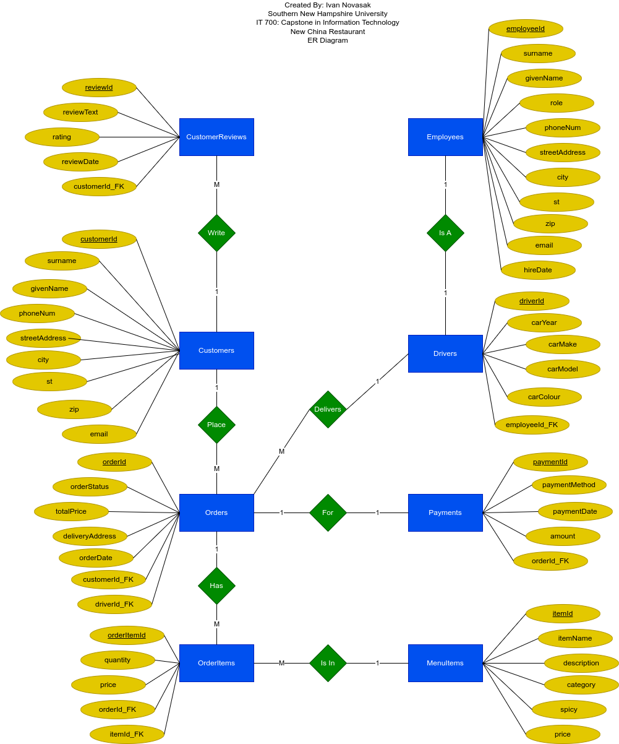

**Backup**

Figures 2 and 3 show screenshots of the ER diagram files backed up into the author’s Google Drive and Dropbox accounts.

**Figure 2**

*Google Drive Backup*

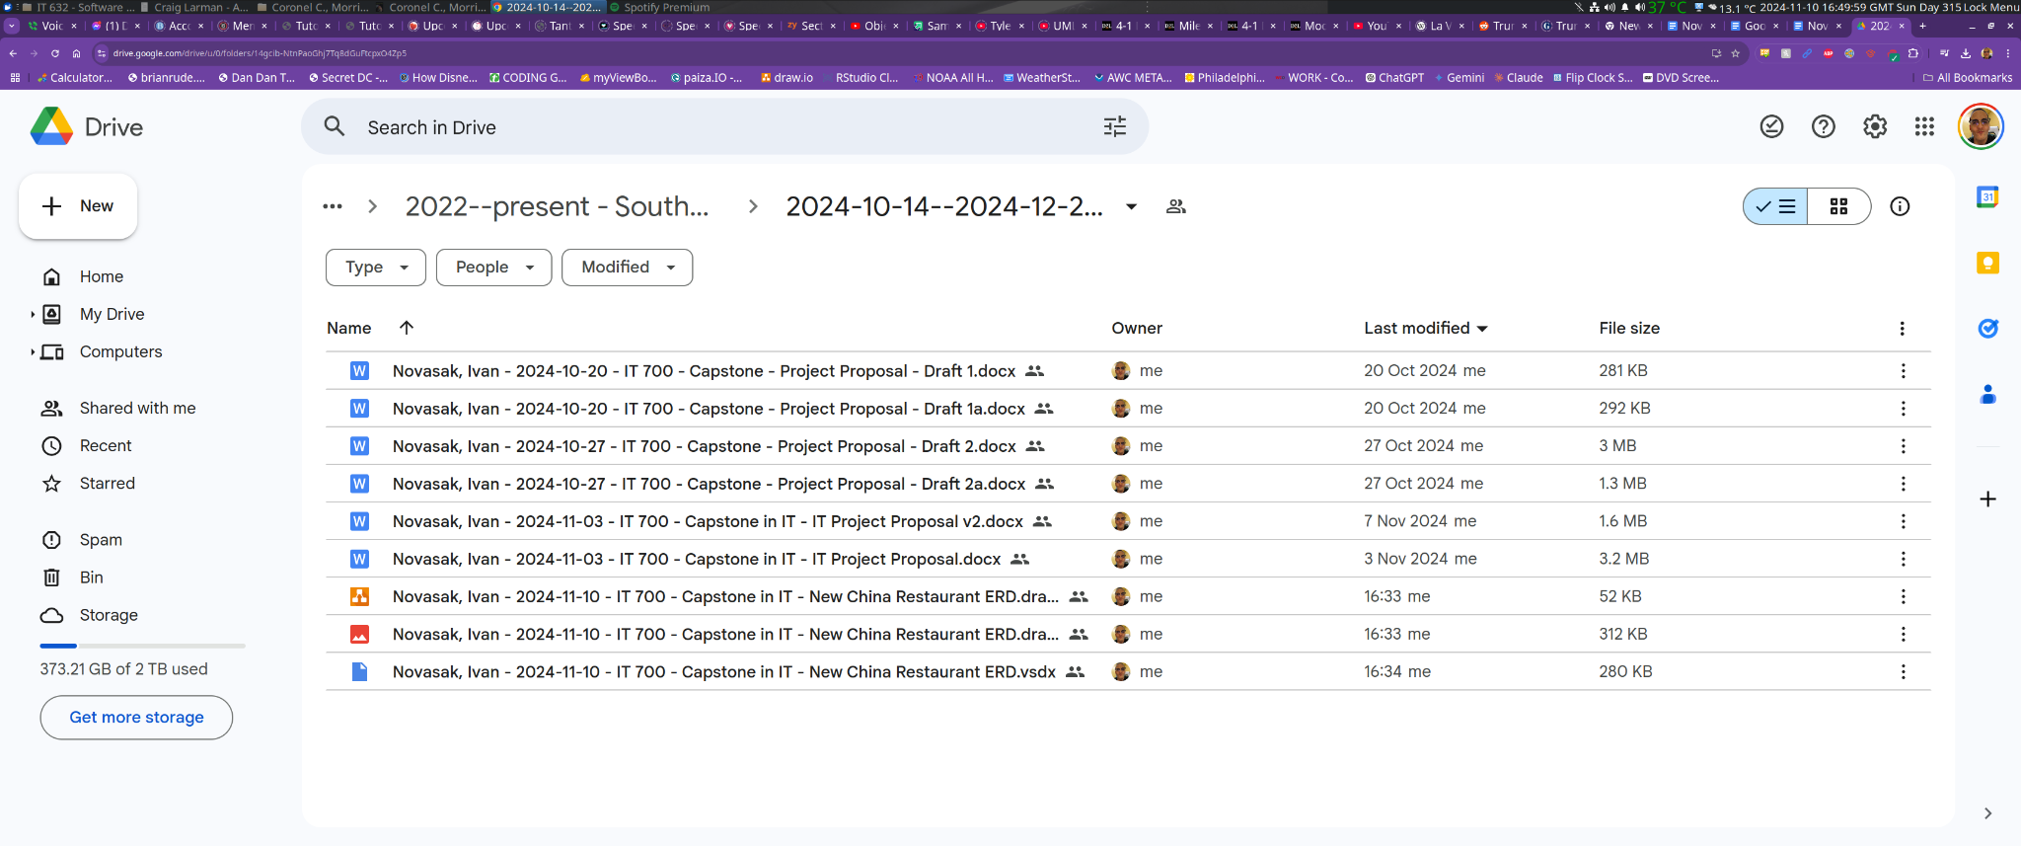

**Figure 3**

*Dropbox Backup*

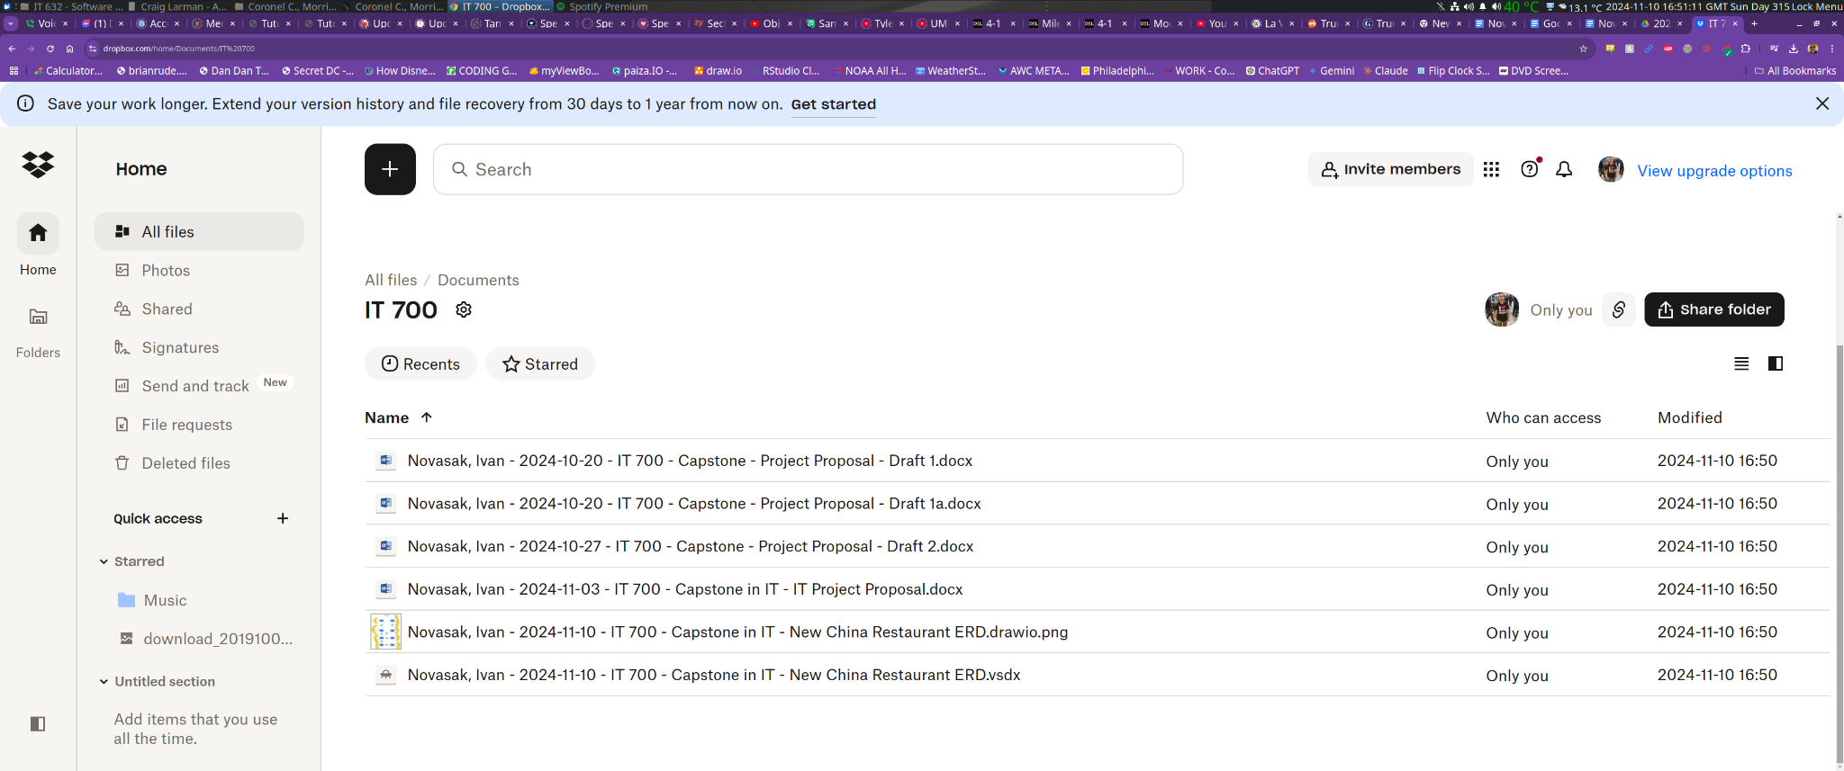

**Project Implementation**

This next section is to show the implementation of the SQL database for New China Restaurant. This includes the draft data dictionary, screenshots of the menu as a Google Sheets spreadsheet, instructions for getting that data into the MariaDB SQL database, and results. Also included is the database code made, including sample data in the code to show a proof of concept that the database is ready to run queries. The database was tested using the actual menu data as well as sample data generated using the Mockaroo web tool.

**From Data Dictionary to Code**

Figures 4–8 contain screenshots of the draft data dictionary in Google Sheets, which shows the purpose of each table in the database as well as a description of the planned attributes within each table.

**Figure 4**

*Screenshot showing the table descriptions and customer attributes*

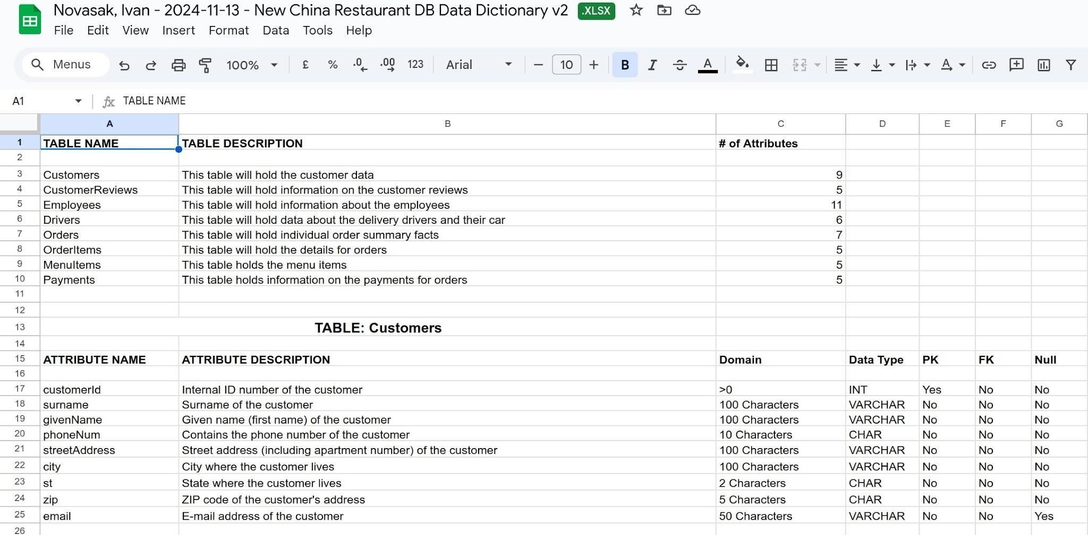

**Figure 5**

*Screenshot showing the attributes for the Customer Reviews and Employees tables*

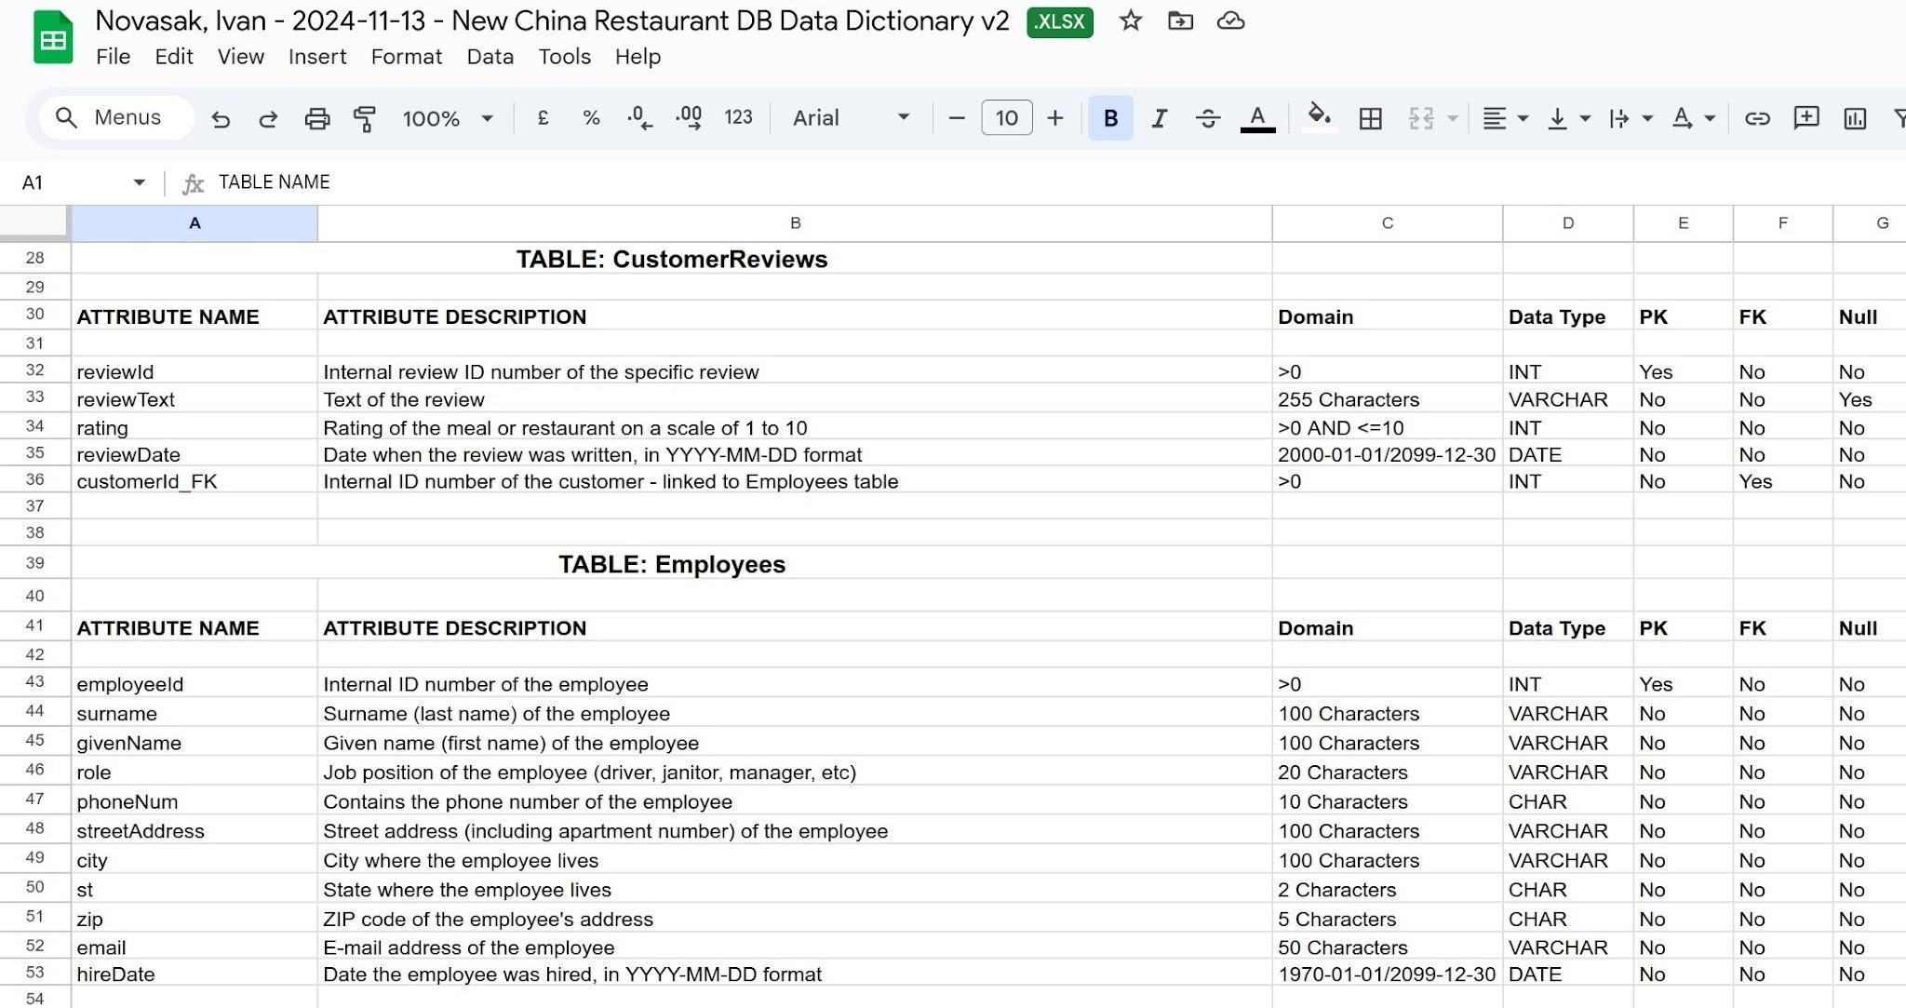

**Figure 6**

*Screenshot showing the attributes for the Drivers and Orders tables*

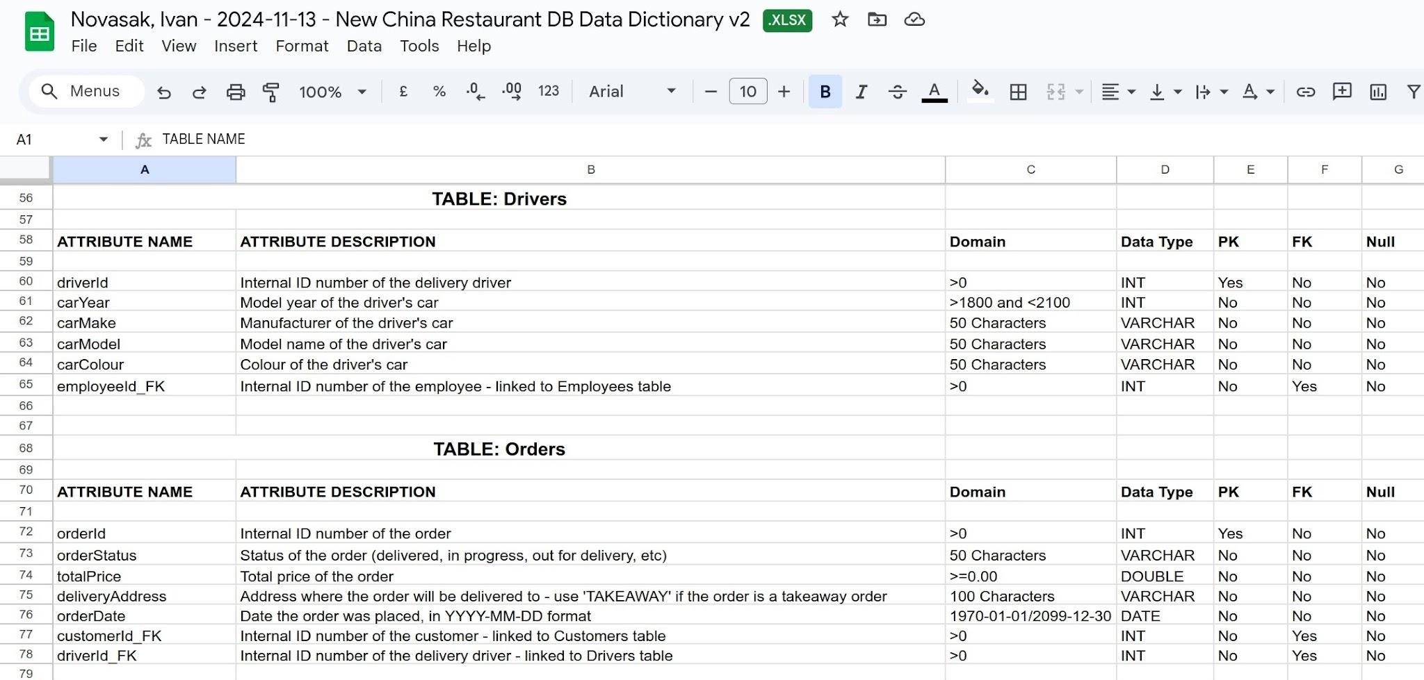

**Figure 7**

*Screenshot showing the attributes for the Menu Items and Order Items tables*

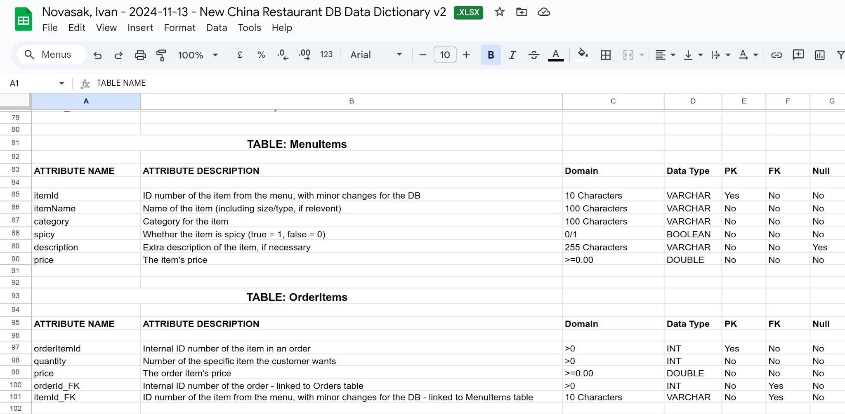

**Figure 8**

*Screenshot showing the attributes for the Payments table*

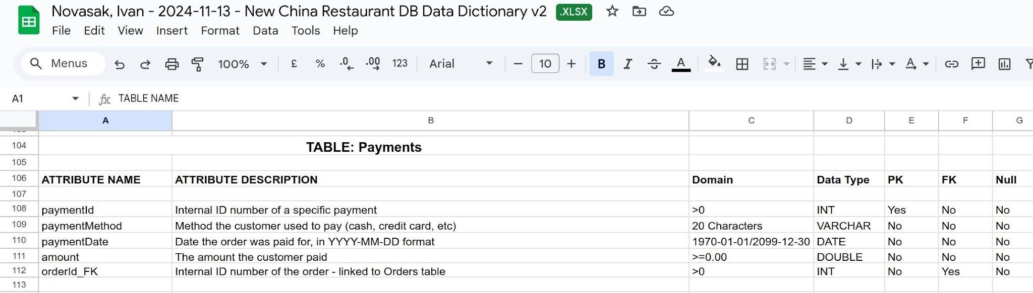

The data contained within the data dictionary, plus some small modifications for compatibility and better currency and time accuracy at the recommendations of Refsnes Data’s W3Schools SQL guide, were typed into a new .sql file in Visual Studio Code, then copied and pasted into an instance of MariaDB in Windows by the author (Refsnes, n.d.).

**Digitising the Menu**

The author typed the menu items into a new Google Sheets spreadsheet, using the numbers on the side of the menu entries plus some modifications for items that would require multiple entries in the database. Figures 9 and 10 show the beginning and the end of the menu spreadsheet, respectively.

**Figure 9**

*Screenshot showing the beginning of the New China Restaurant menu spreadsheet*

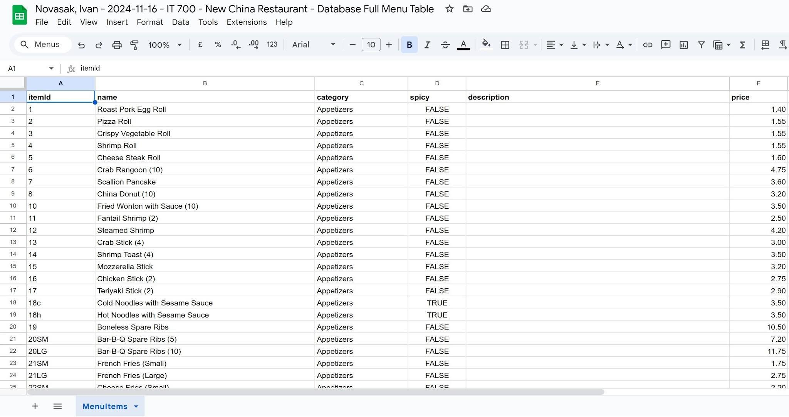

**Figure 10**

*Screenshot showing the end of the New China Restaurant menu spreadsheet*

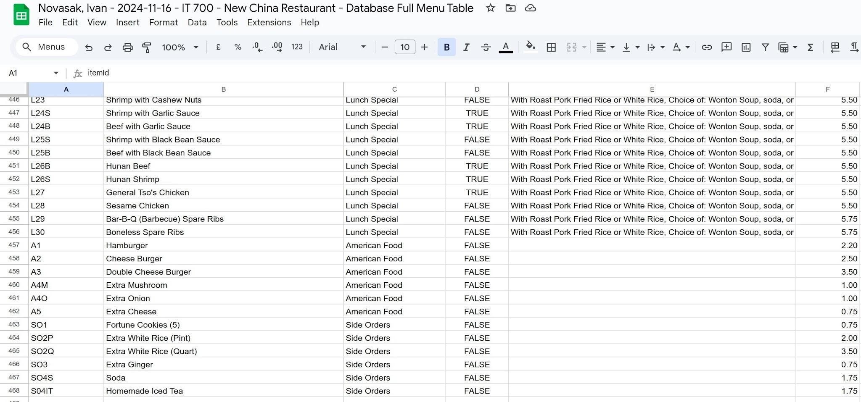

A Microsoft Excel spreadsheet file with the full menu data will be included with this document.

**From Google Sheets to Data in the Database**

To get the menu data from Google Sheets into the database as SQL code, the author first chose to download the data in Microsoft Excel format, then open it in LibreOffice, then export the spreadsheet in CSV format, using the £ character as a field delimiter, because the comma and semicolon were already being used in menu items. The author then searched on Google for how to import a CSV file into an SQL database as a table and used the guide by Simplified Guide which shows how to do it using MariaDB and MySQL, the database software the author is most familiar with and is coding the database in (Simplified Guide, n.d.).

**Issues With Using Actual Menu Data in the Database**

The author experienced some issues with getting the actual menu items’ data into the database correctly such that further data can be added. They tried to work around it by using a different delimiter symbol when generating the CSV file from the Excel spreadsheet, but the database software still is giving an error. One thing that could be checked is if the descriptions have ‘NULL’ entries in the CSV file where nothing needed to be entered for a particular record, then attempt to run the database again after fixing the CSV file using the Fine & Replace feature in Mousepad, Notepad, or Visual Studio Code. Some queries can still be run however, and as such they are demonstrated in the following sections.

**Project Test Plans and Results**

Two versions of the database were used for running queries due to an issue the author had with getting the menu data into the database from the CSV file. The first version of the database will have only one table with data in it: the menu items using the real menu’s data. Despite having only one table to query against in this database, some useful queries can still be run, such as getting the average, maximum, and minimum price items, a listing of all items that are not spicy, etc.

The second version of the database will contain sample data in multiple tables, with the MenuItems table containing sample data generated from Mockaroo to demonstrate running queries that get data from more than one table.

**Query Results Using the Real MenuItems Data**

The following queries are run using the restaurant’s menu data (Refsnes Data, n.d.):

1. Display the average item price
2. Display a list of all menu items that are not spicy (item ID, name, category, price) that also cost less than $20. Sort on category.
3. Display the number of items that are spicy
4. Display the most expensive item (ID, name, category) and its price

Figures 11–14 display the results of the query runs:

**Figure 11**

*Screenshot showing the average item price query result*

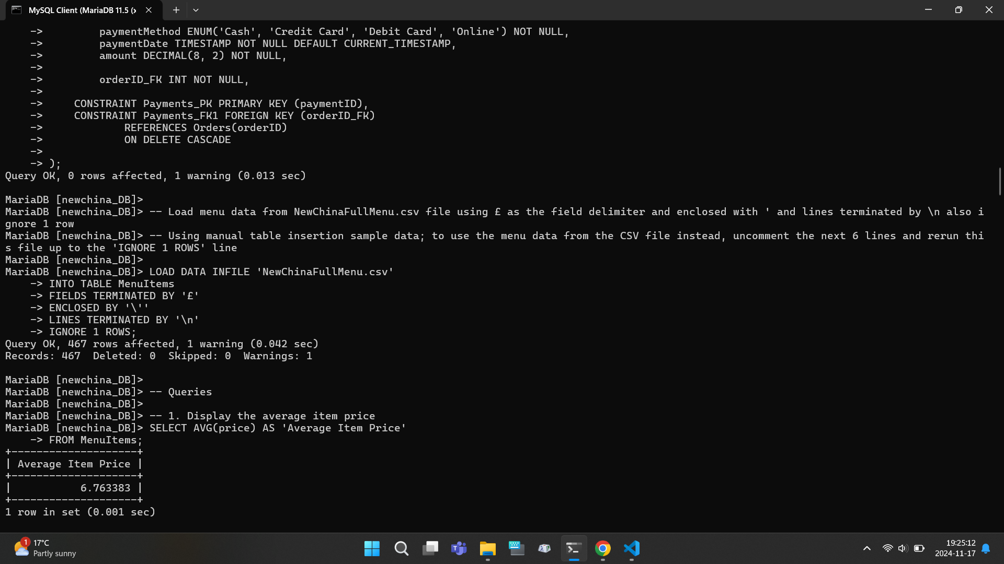

**Figure 12**

*Screenshot showing the beginning of the listing of all menu items that are not spicy (item ID, name, category, price) that also cost less than $20, sorted on category*

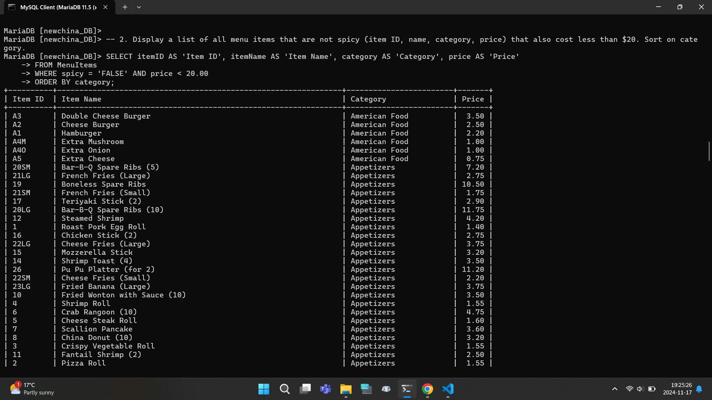

**Figure 13**

*Screenshot showing the end of the listing of all menu items that are not spicy (item ID, name, category, price) that also cost less than $20, sorted on category*

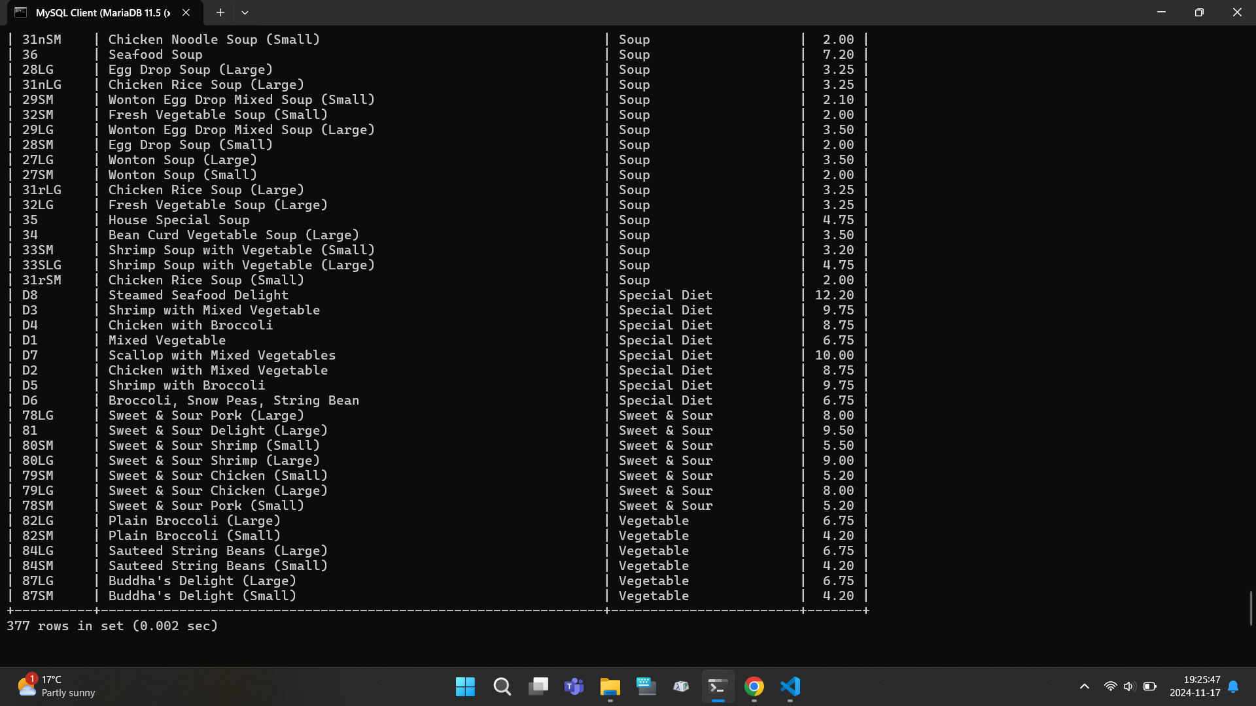

**Figure 14**

*Screenshot showing the number of spicy items and the most expensive item query results*

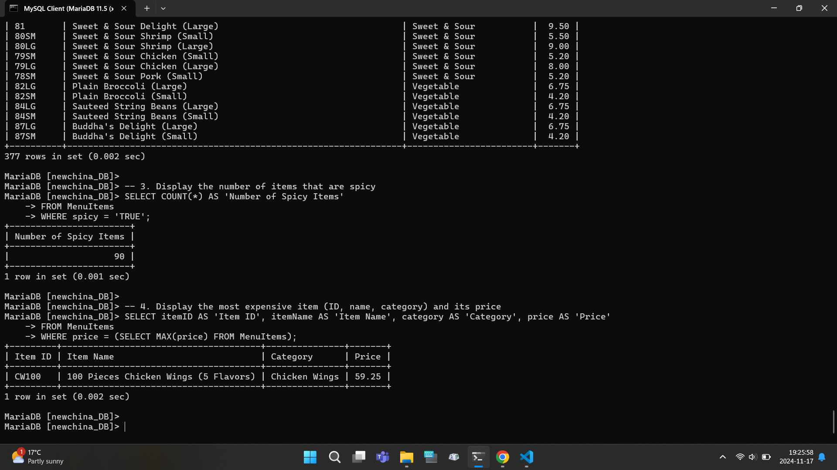

**Query Results Using the Mockaroo Sample MenuItems Data**

The following queries are for the database using the sample data, not the real menu data to demonstrate queries using other tables besides the MenuItems one:

1. Display a listing of all completed orders including the customer’s name, delivery address, phone number, and total price
2. Display the customer reviews showing the name of the customer, rating, review text, and review date
3. Display the average total order amount
4. Display the names and categories of the items in order ID #1
5. Write a query to add a new order to the database. Display the results.

Figures 15–17 display the results of these queries:

**Figure 15**

*Screenshot showing the completed orders and customer reviews query results*

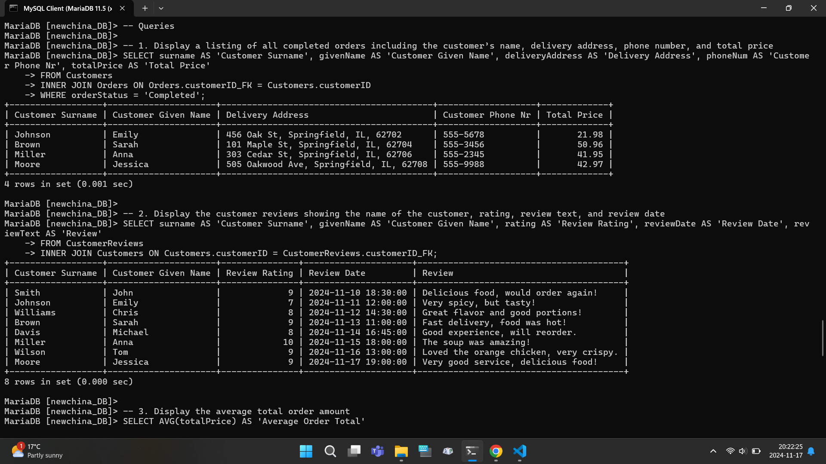

**Figure 16**

*Screenshot showing the results for the average total order amount, names/categories for order #1, and the first steps of adding a new order to the database*

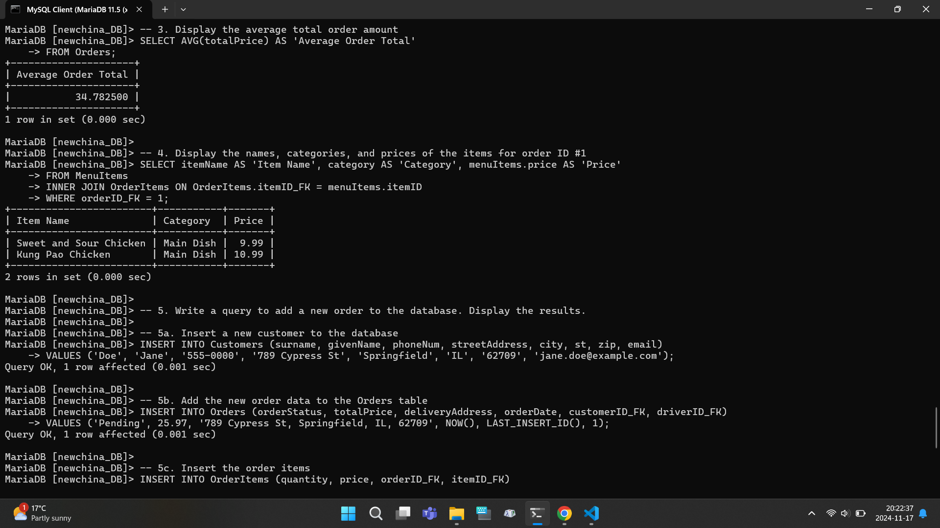

**Figure 17**

*Screenshot showing the last steps for adding a new order and the results showing the new order’s customer name, total price, and date/time*

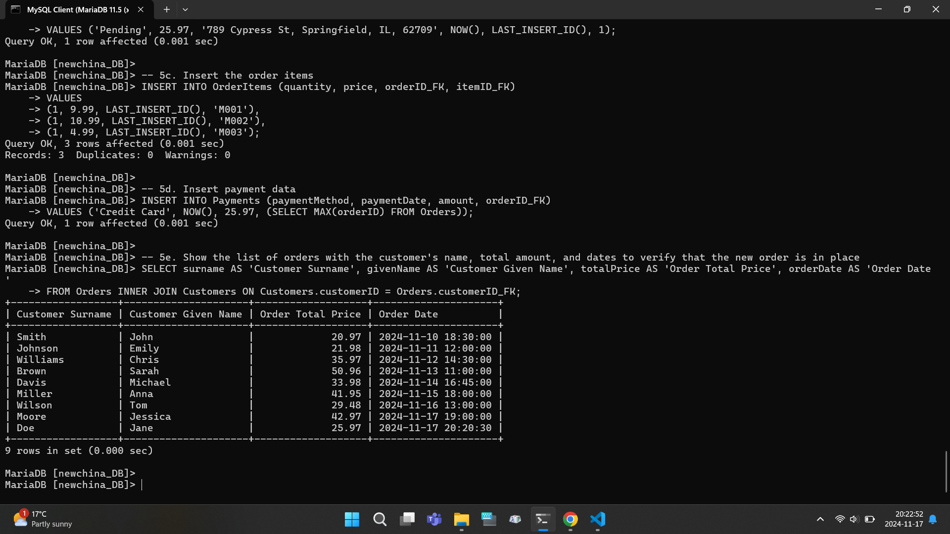

**Report Summary**

Most of the work for creating the database was transcribing the restaurant’s menu into a Google Spreadsheet, followed by making the initial ER diagram from the business rules, then the data dictionary followed by coding and testing. Transcribing the menu took approximately 8 hours, creating the ER diagram 3 hours, writing the data dictionary 2 hours, acquiring sample table data 1 hour, coding 4 hours (split into 2 instances - one for each version of the database), and testing 3 hours (90 minutes for each database version).

**Recommendations for Future Enhancements**

The next sections are for recommending any future enhancements or modifications to the database or new features; and the appendix, which contain screenshots of the revised data dictionary, revised ER diagram, MariaDB command line output, and the database running in two GUI programs: DBeaver and HeidiSQL.

**Successes, Challenges, and Lessons Learned**

The main success is that a functional database was created, and it works well for viewing and entering new orders. The top challenge was getting the menu items into the database and dealing with the column that could have a lot of null entries: the item descriptions. It works now after adding customers, delivery drivers, and orders into the database. The main lesson learned is to try to create a smaller proof-of-concept model before making a bigger model that could be used in the real environment.

**Modification Strategies and Actionable Steps**

There are two things the author was considering doing differently during the development of this database: a) using optical character recognition to scan the restaurant menu instead of manually typing the entries into a spreadsheet, and b) run the database code by the author’s previous database professor at Community College of Philadelphia, Craig Nelson, who is experienced at making databases. The former could have saved time which could have allowed more time to implement one feature that is now slated for a possible future expansion: giving customer discounts based on the total order amount, and customer loyalty. The latter could have more easily allowed the spotting of errors in adding new orders and defining the attribute data types. This project is still quite close to the intended vision. The entity-relationship diagram and data dictionary now reflect the final data types and fix one of the relationships in the diagram (the OrderItems table is a junction table that reflects a many-to-many relationship between the Orders and MenuItems tables; it is listed in the original diagram as two one-to-many relationships with both one menu item is in many OrderItems, and one Order has many OrderItems). Other enhancements that could be made include:

* More checking of entered data values, such as forcing the database to check that all orders have a total price above 0.00
* Implementation of sales tax calculations
* Price history of the items over time

**Potential Issues**

The database still needs a more consumer-friendly frontend application for running it, as the two GUIs introduced in this paper, DBeaver and HeidiSQL, are more ideal for database engineers who already know a lot about which commands to issue. If this project were longer, plans would need to be made to hire a software developer to create a more friendly user interface. At the same time, another possible expansion would be to automate the database order entries with the transaction system so that when people pay for their orders, the database is automatically updated.

**Appendix**

**Revised ER Diagram**

Figure 18 shows the revised ER diagram that is based on the database code and a correction to the relationship between the Orders and MenuItems tables.

**Figure 18**

*Revised ER Diagram*

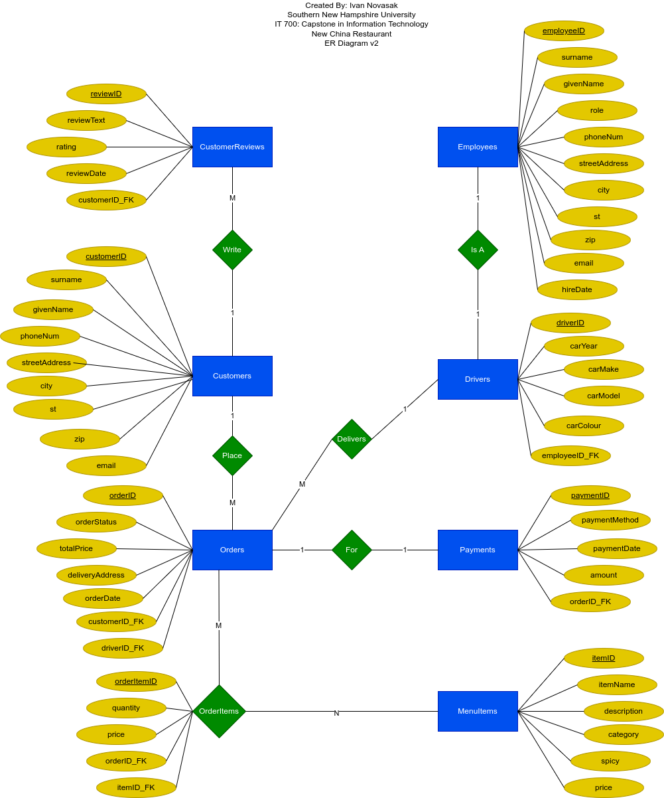

**Revised Data Dictionary**

Figures 19–23 show Google Sheets screenshots of the revised data dictionary that is based on the database code.

**Figure 19**

*Data dictionary showing table descriptions and Customers table metadata*

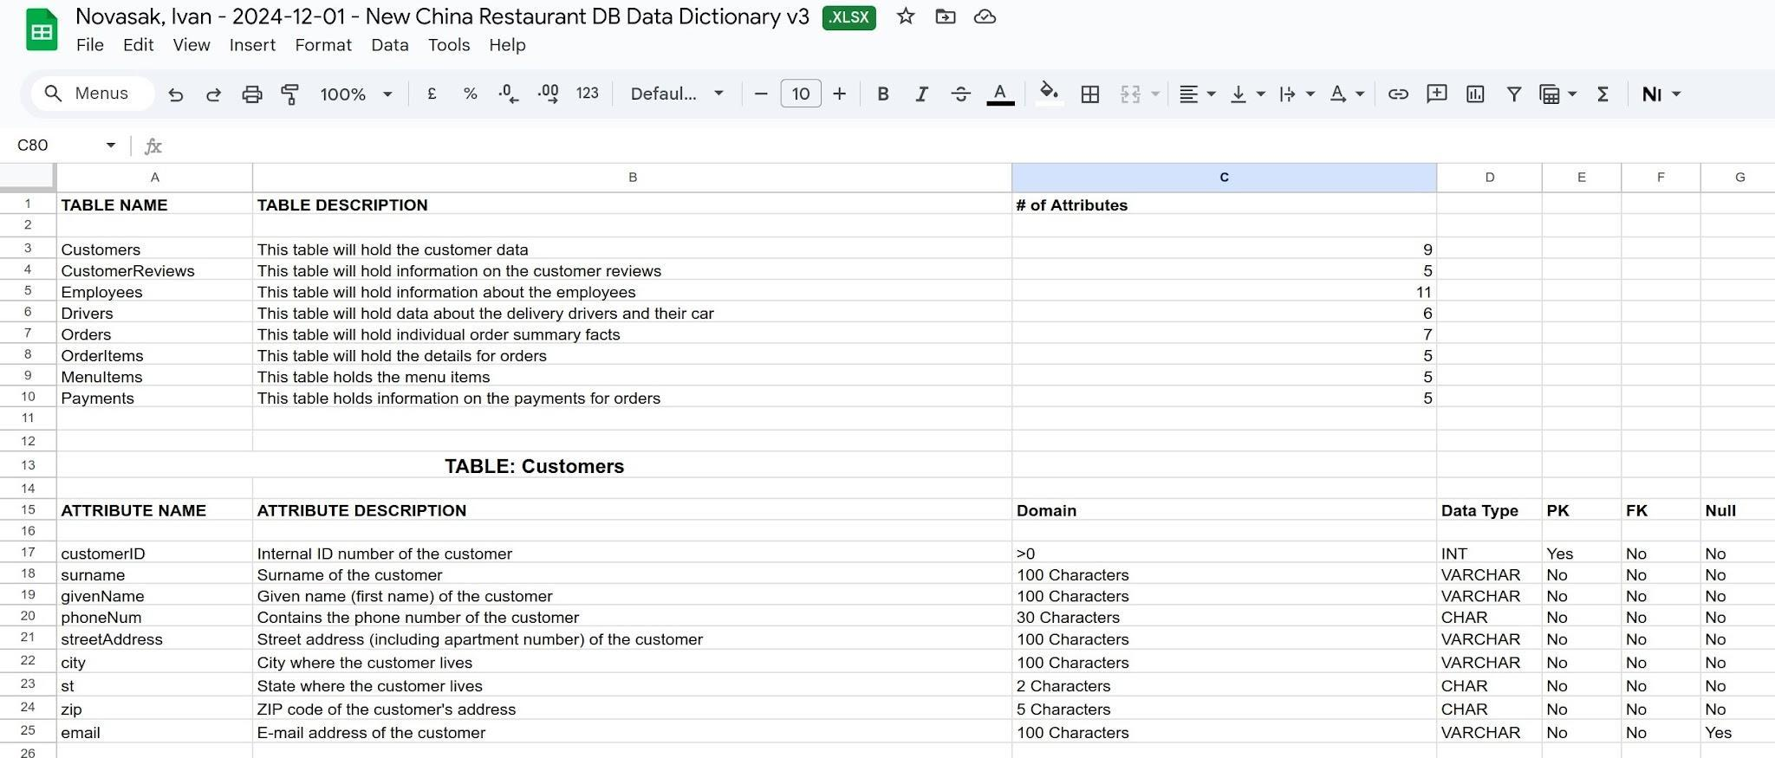

**Figure 20**

*Data dictionary showing CustomerReviews and Employees tables’ metadata*

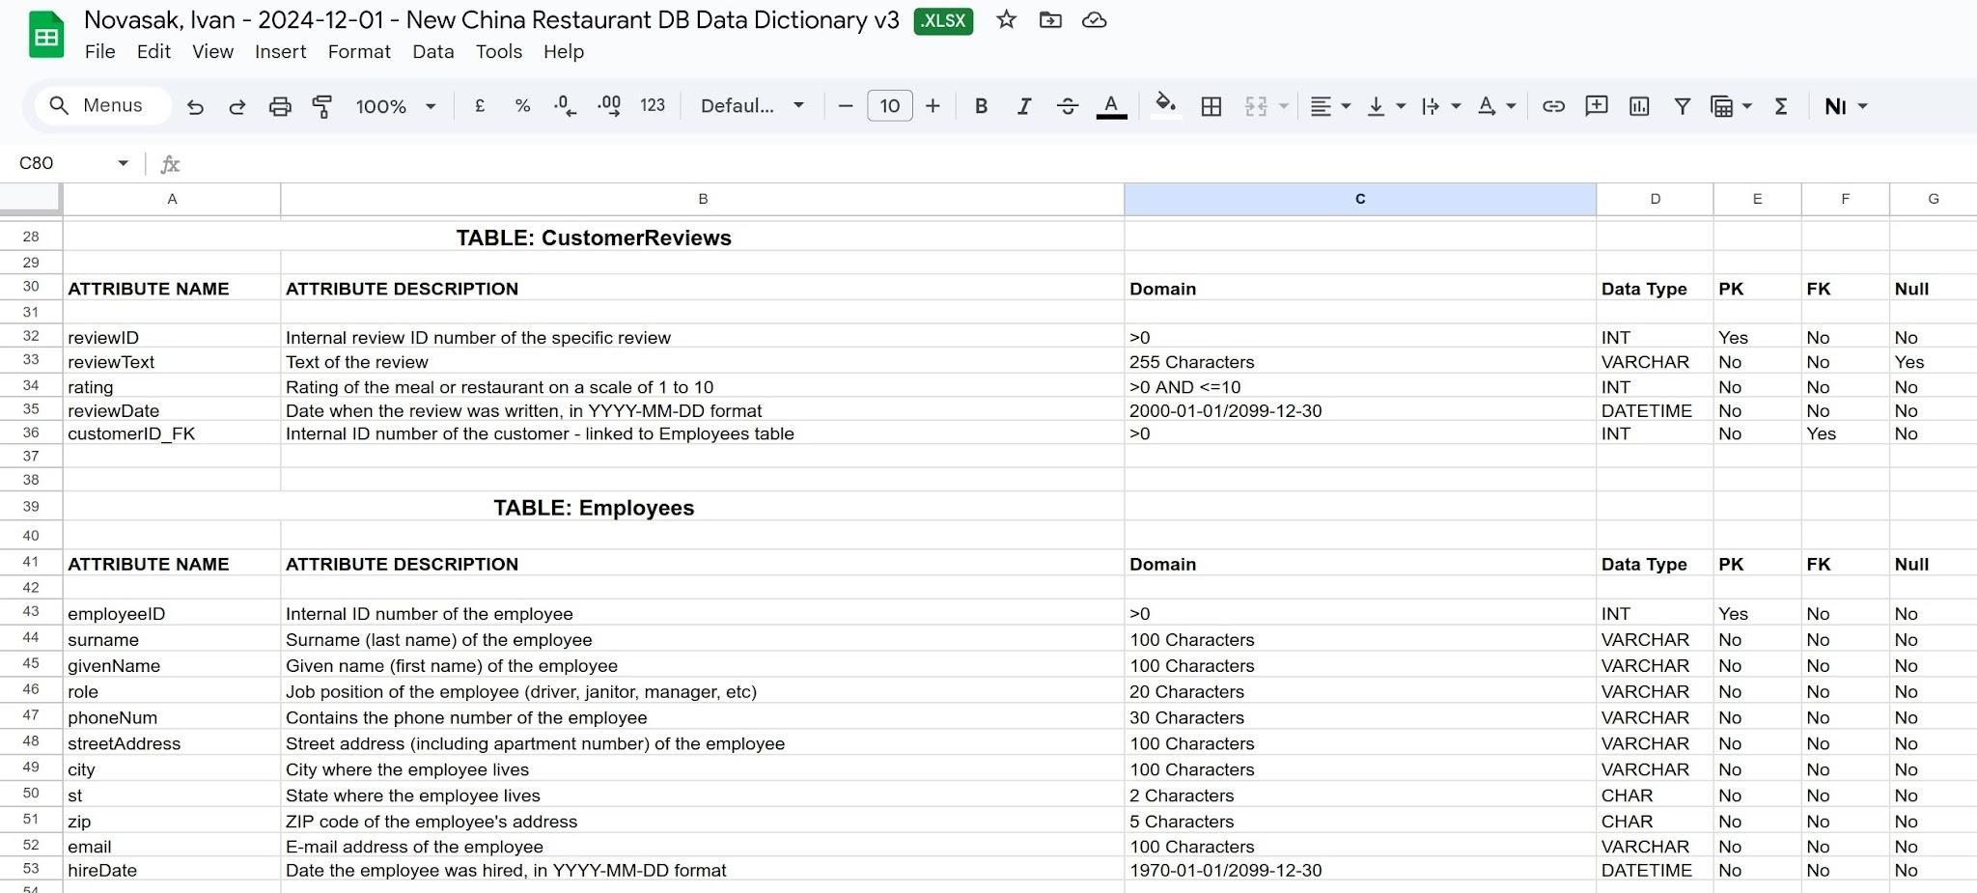

**Figure 21**

*Data dictionary showing Drivers and Orders tables’ metadata*

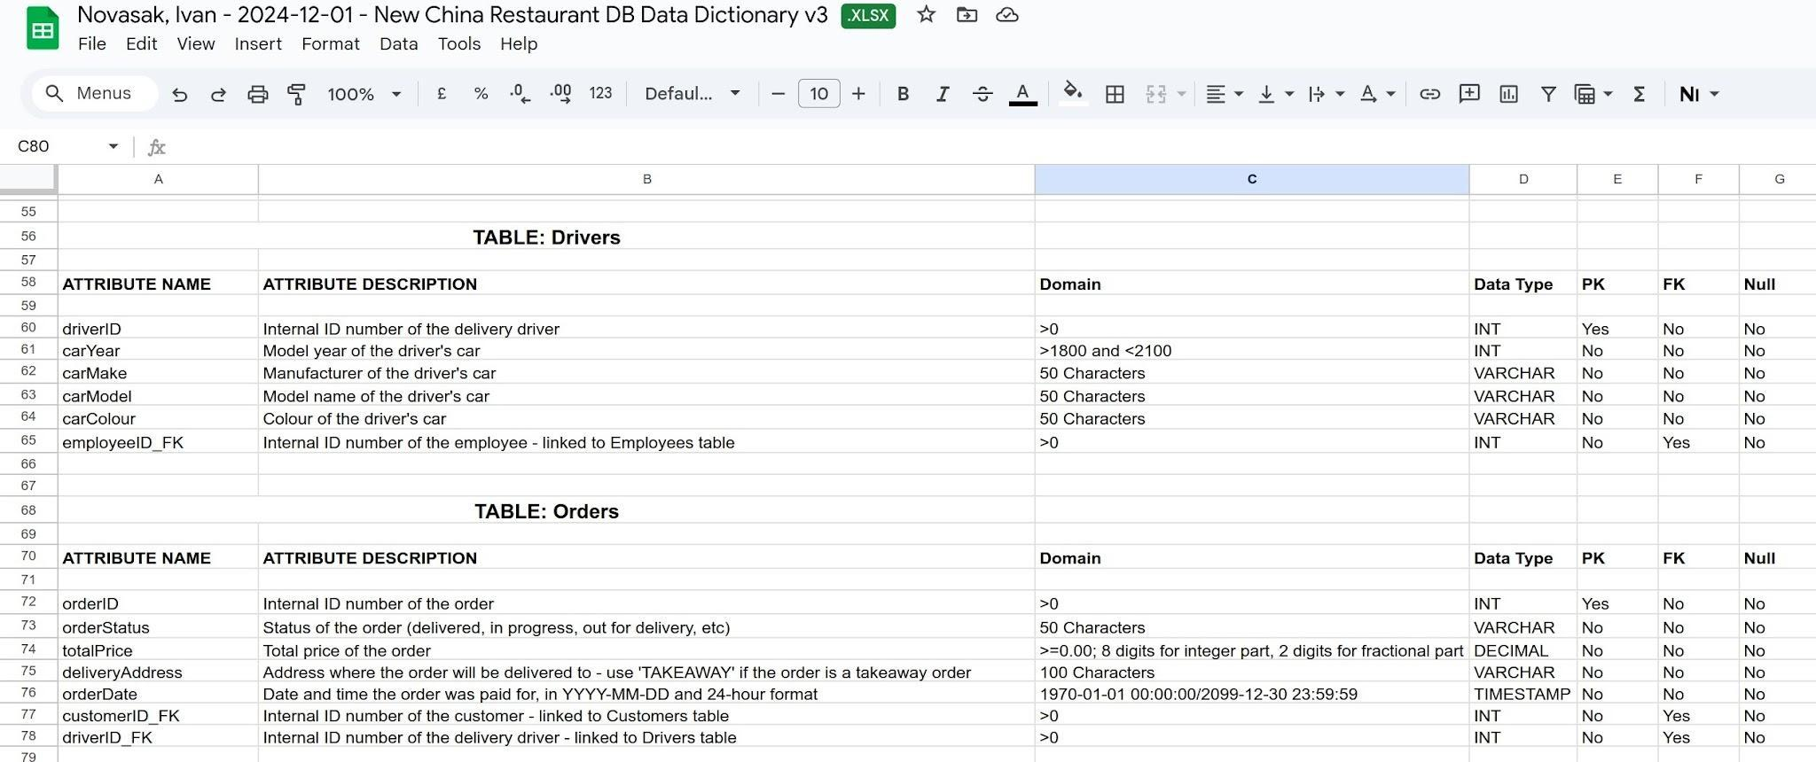

**Figure 22**

*Data dictionary showing MenuItems and OrderItems tables’ metadata*

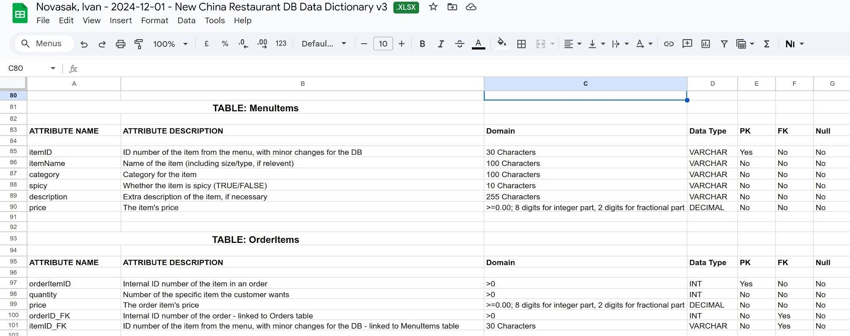

**Figure 23**

*Data dictionary showing Payments table metadata*

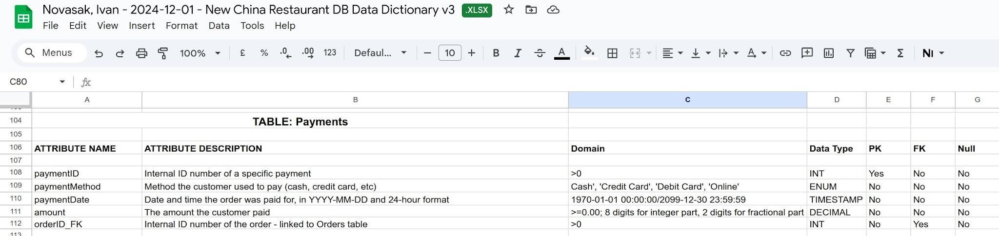

**Menu Items Table Sample Data**

Figures 24 and 25 show Google Sheets screenshots of the beginning and end of the MenuItems data table for the New China Restaurant.

**Figure 24**

*Beginning of the MenuItems table*



**Figure 25**

*End of the MenuItems table*



**MariaDB Command Line Output**

Figures 26–35 show screenshots of the MariaDB command line output for two versions of the database: one version using the New China Restaurant MenuItems table and another using a smaller sample MenuItems table along with other sample data to make the database function.

**Figure 26**

*Query output for average item price in New China Restaurant MenuItems table*



**Figure 27**

*Query output for showing New China Restaurant MenuItems that are non-spicy and cost less than $20, sorted on category (start of listing)*



**Figure 28**

*Query output for showing New China Restaurant MenuItems that are non-spicy and cost less than $20, sorted on category (end of listing)*



**Figure 29**

*Query output to show the most expensive item at New China Restaurant*



**Figure 30**

*Sample data insertion commands into other database for testing purposes: Customers, Employees, and MenuItems tables*

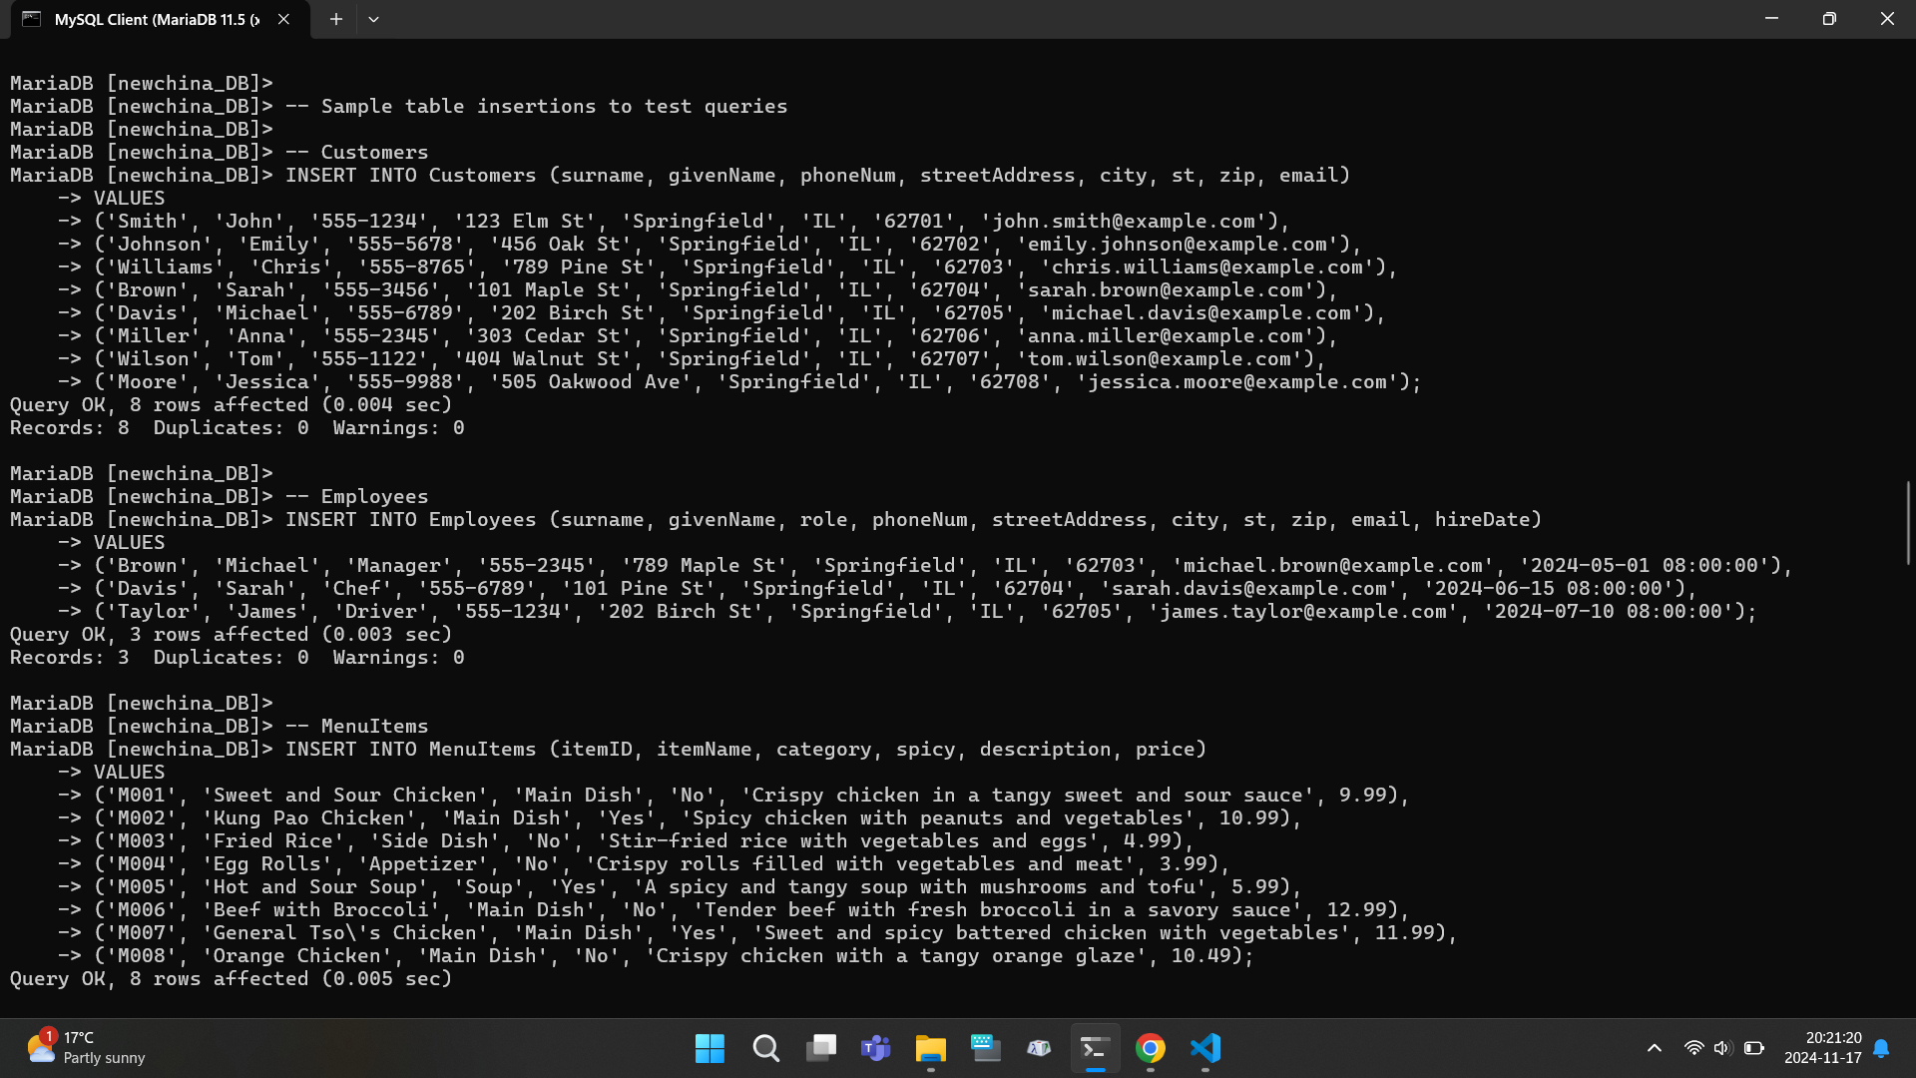

**Figure 31**

*Sample data insertion commands into other database for testing purposes: CustomerReviews, Drivers, and Orders tables*

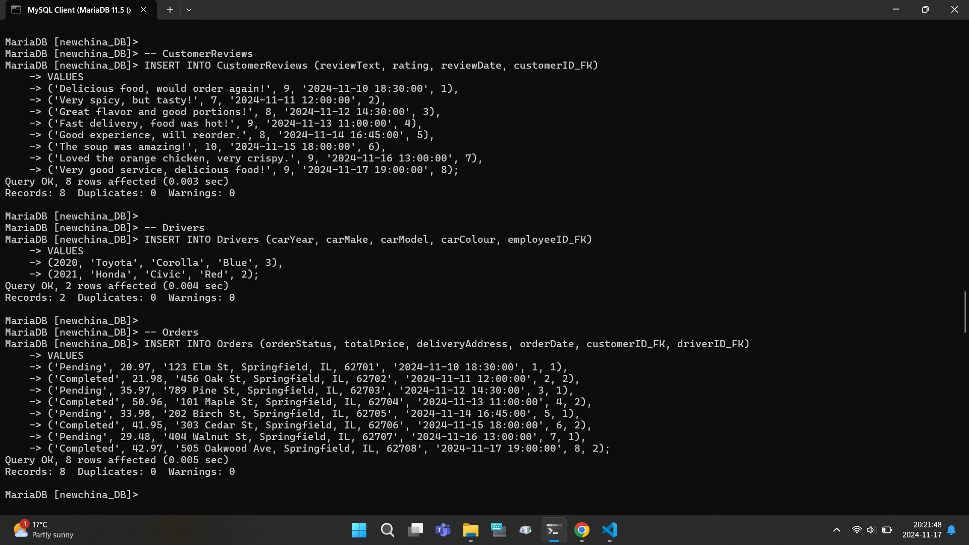

**Figure 32**

*Sample data insertion commands into other database for testing purposes: OrderItems and Payments tables*

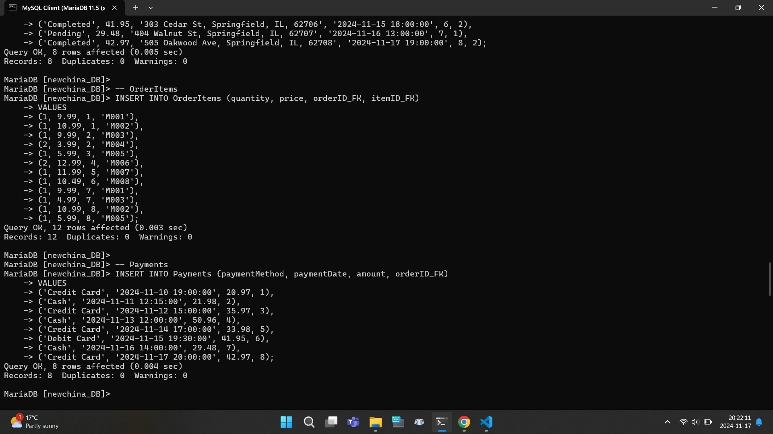

**Figure 33**

*Query outputs for other database: showing completed orders and customer reviews data*



**Figure 34**

*Query outputs for other database: showing average total order amount, display of items in a specific order, and the first part of a command to add a new order to the database*



**Figure 35**

*The second part of a command to add a new order to the database, checking to verify the new order was added*



**DBeaver Screenshots**

Figures 36 and 37 show screenshots of the database running in the DBeaver GUI tool. Figure 37 is an ER diagram generated by DBeaver to demonstrate the feature of diagram generation from the database code.

**Figure 36**

*DBeaver screenshot showing the Customers table in the database*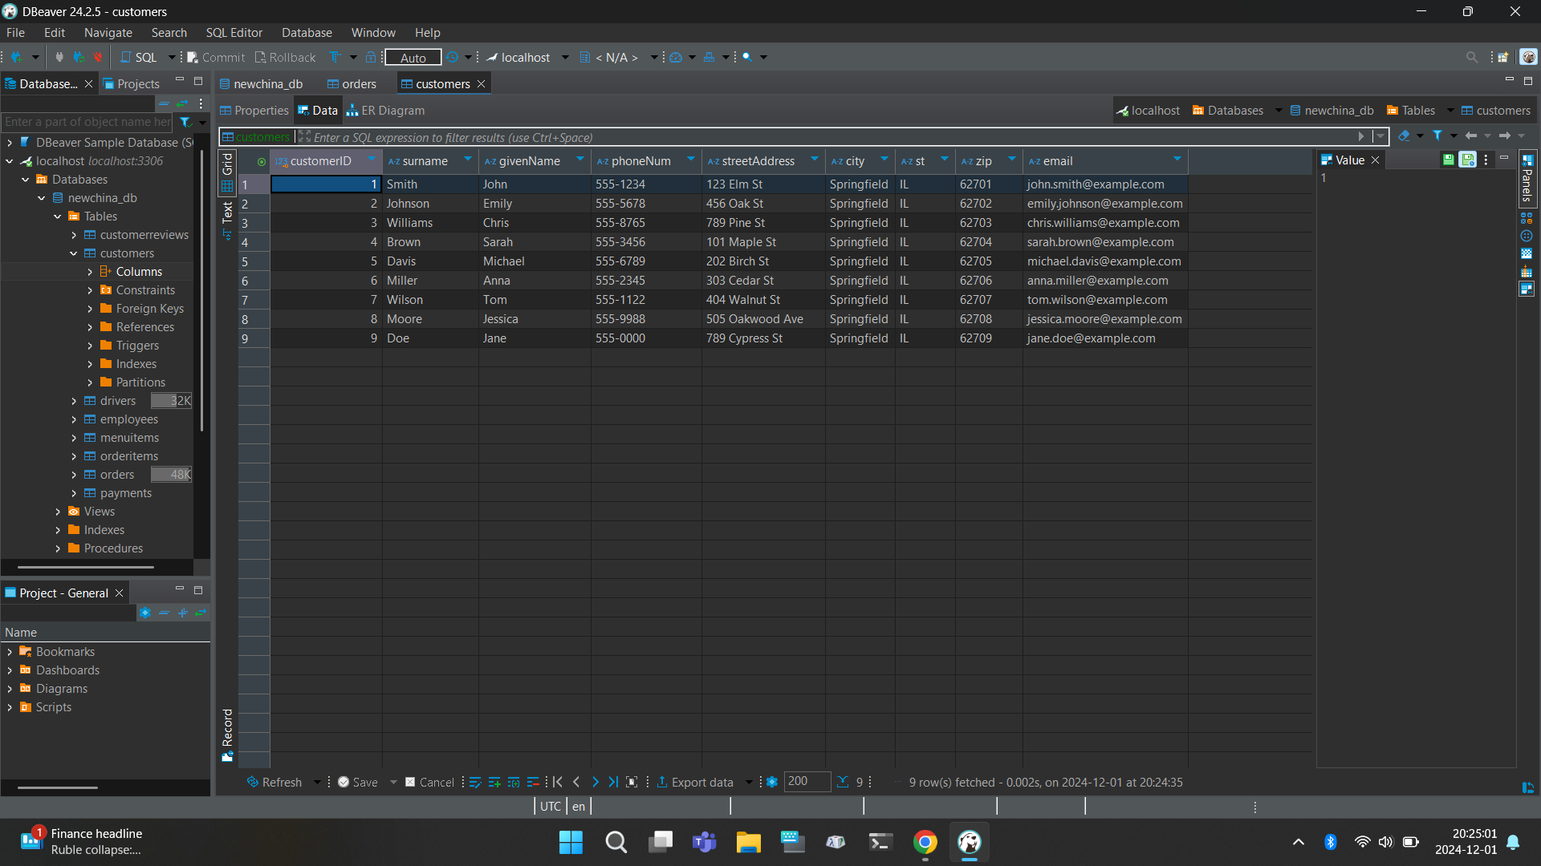

**Figure 37**

*DBeaver-generated ER Diagram from the database code (compare with the manually made ones in Figures 1 and 18)*

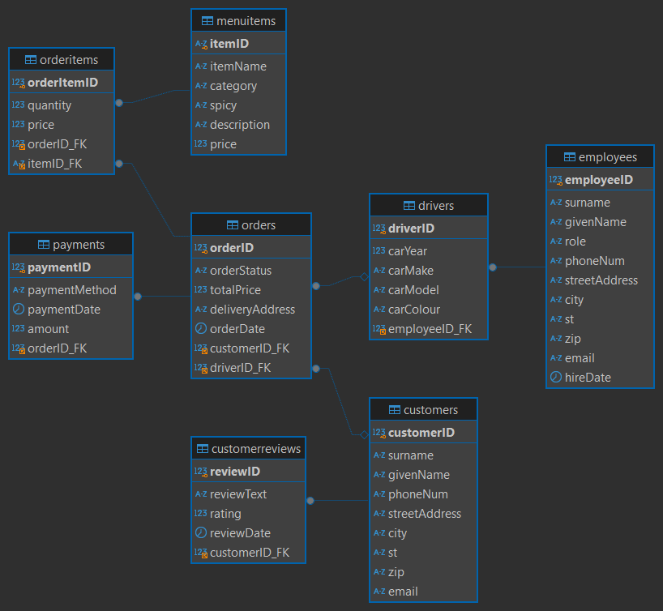

**HeidiSQL Screenshot**

HeidiSQL is another GUI tool for SQL database management. A screenshot of its functionality is shown in Figure 38. HeidiSQL does not appear to have ER Diagram generation from code support.

**Figure 38**

*HeidiSQL screenshot showing the MenuItems table in the database*

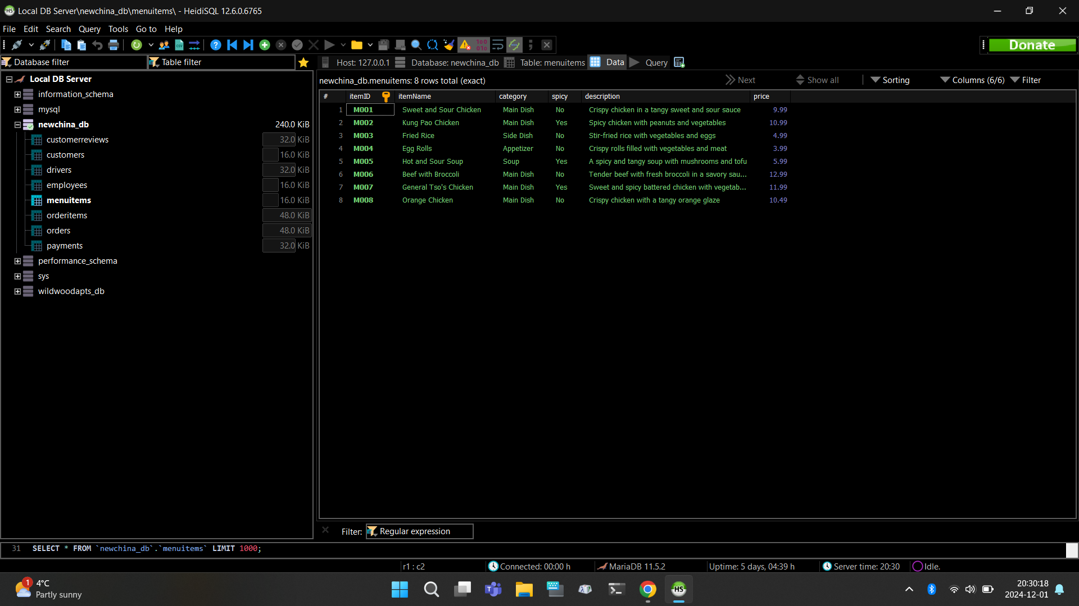

**Data Backup Screenshots**

Figures 39 - 42 show screenshots of the backup tools used to back up and archive the database development files and data. Figures 39 and 40 show Dropbox being used, with Figures 41 and 42 showing Google Drive.

**Figure 39**

*Dropbox screenshot #1 of backup data*

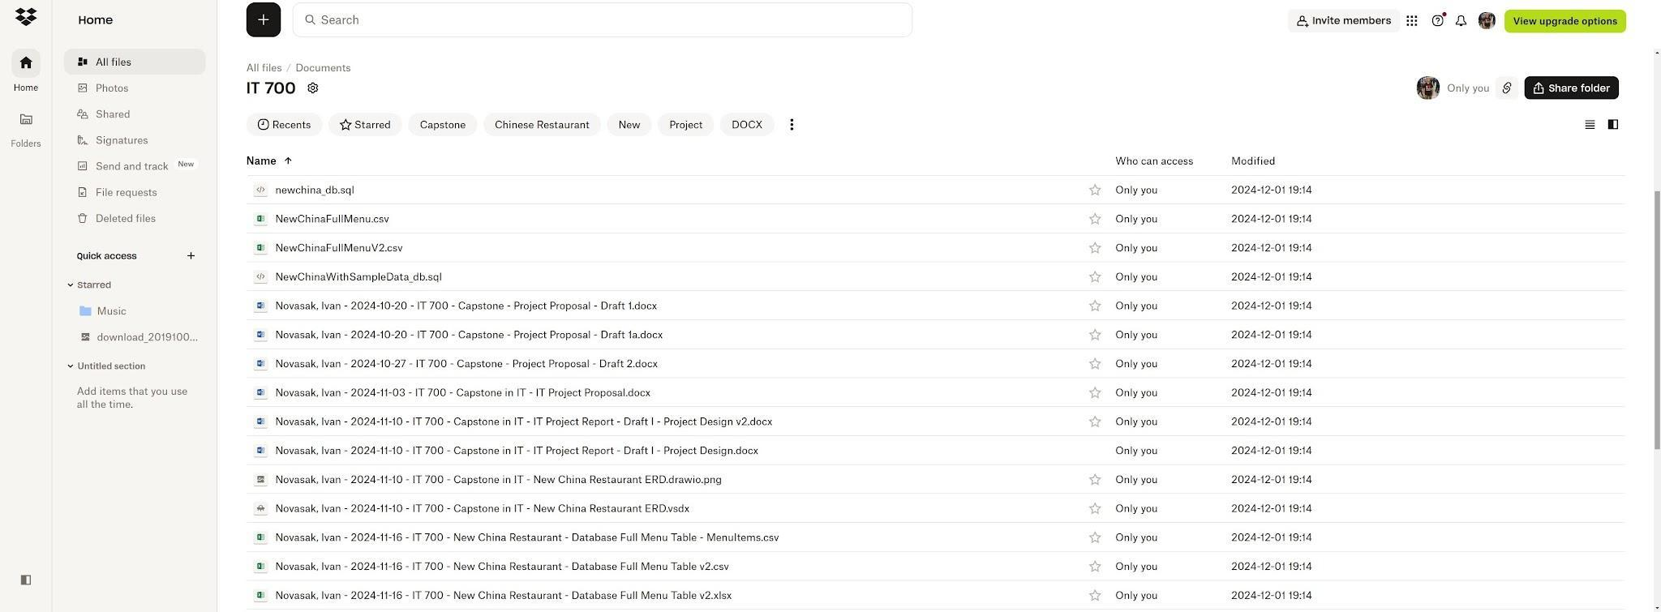

**Figure 40**

*Dropbox screenshot #2 of backup data*

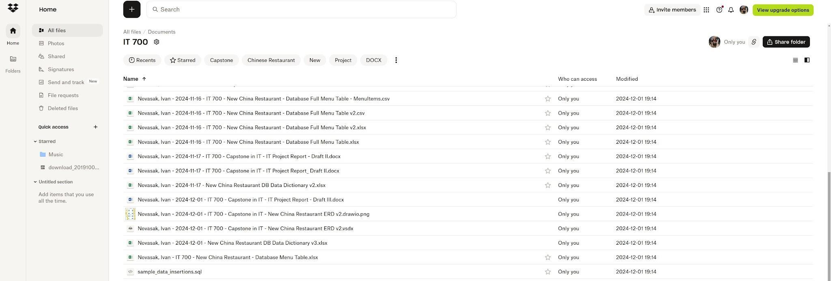

**Figure 41**

*Google Drive screenshot #1 of backup data*

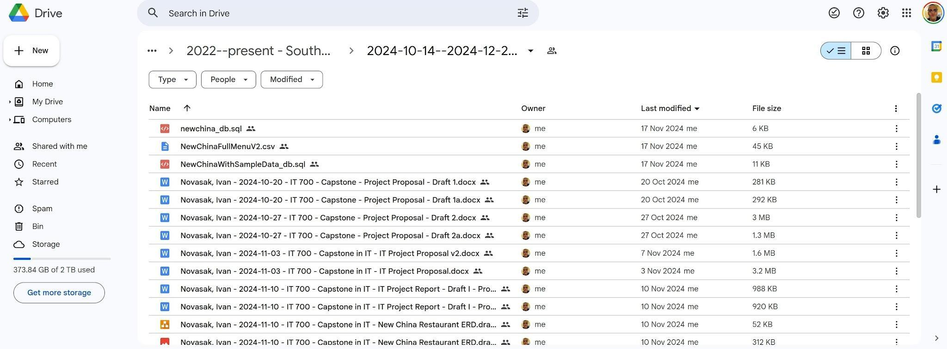

**Figure 42**

*Google Drive screenshot #2 of backup data*

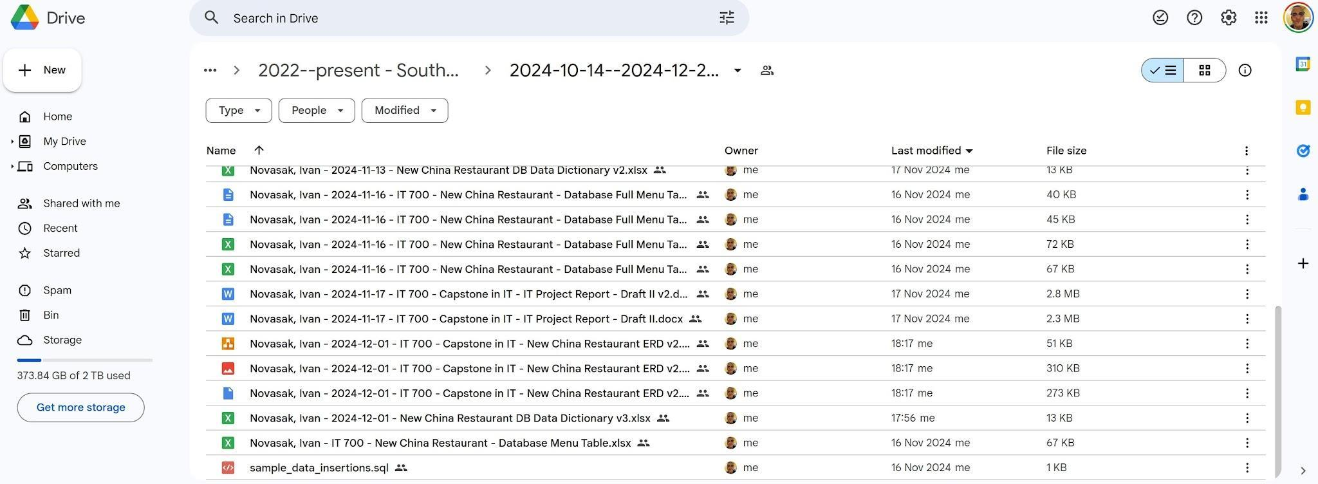

**New China Restaurant Menu Photos**

Figures 43 and 44 show photos of the New China Restaurant menu. These were used to type the restaurant database’s MenuItems table.

**Figure 43**

*Photo of the outside of New China Restaurant menu*

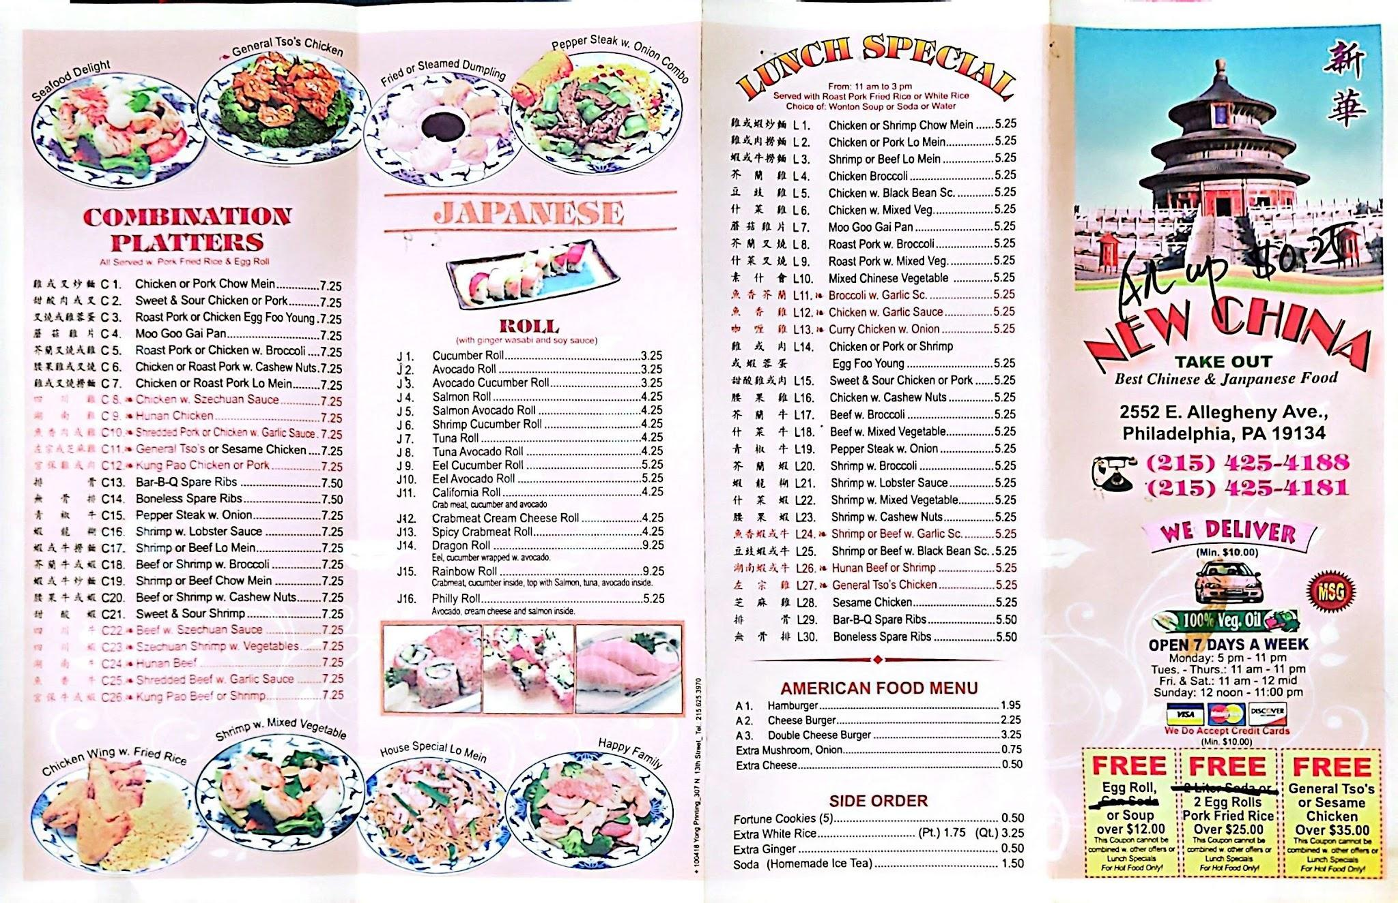

**Figure 44**

*Photo of the inside of New China Restaurant menu*

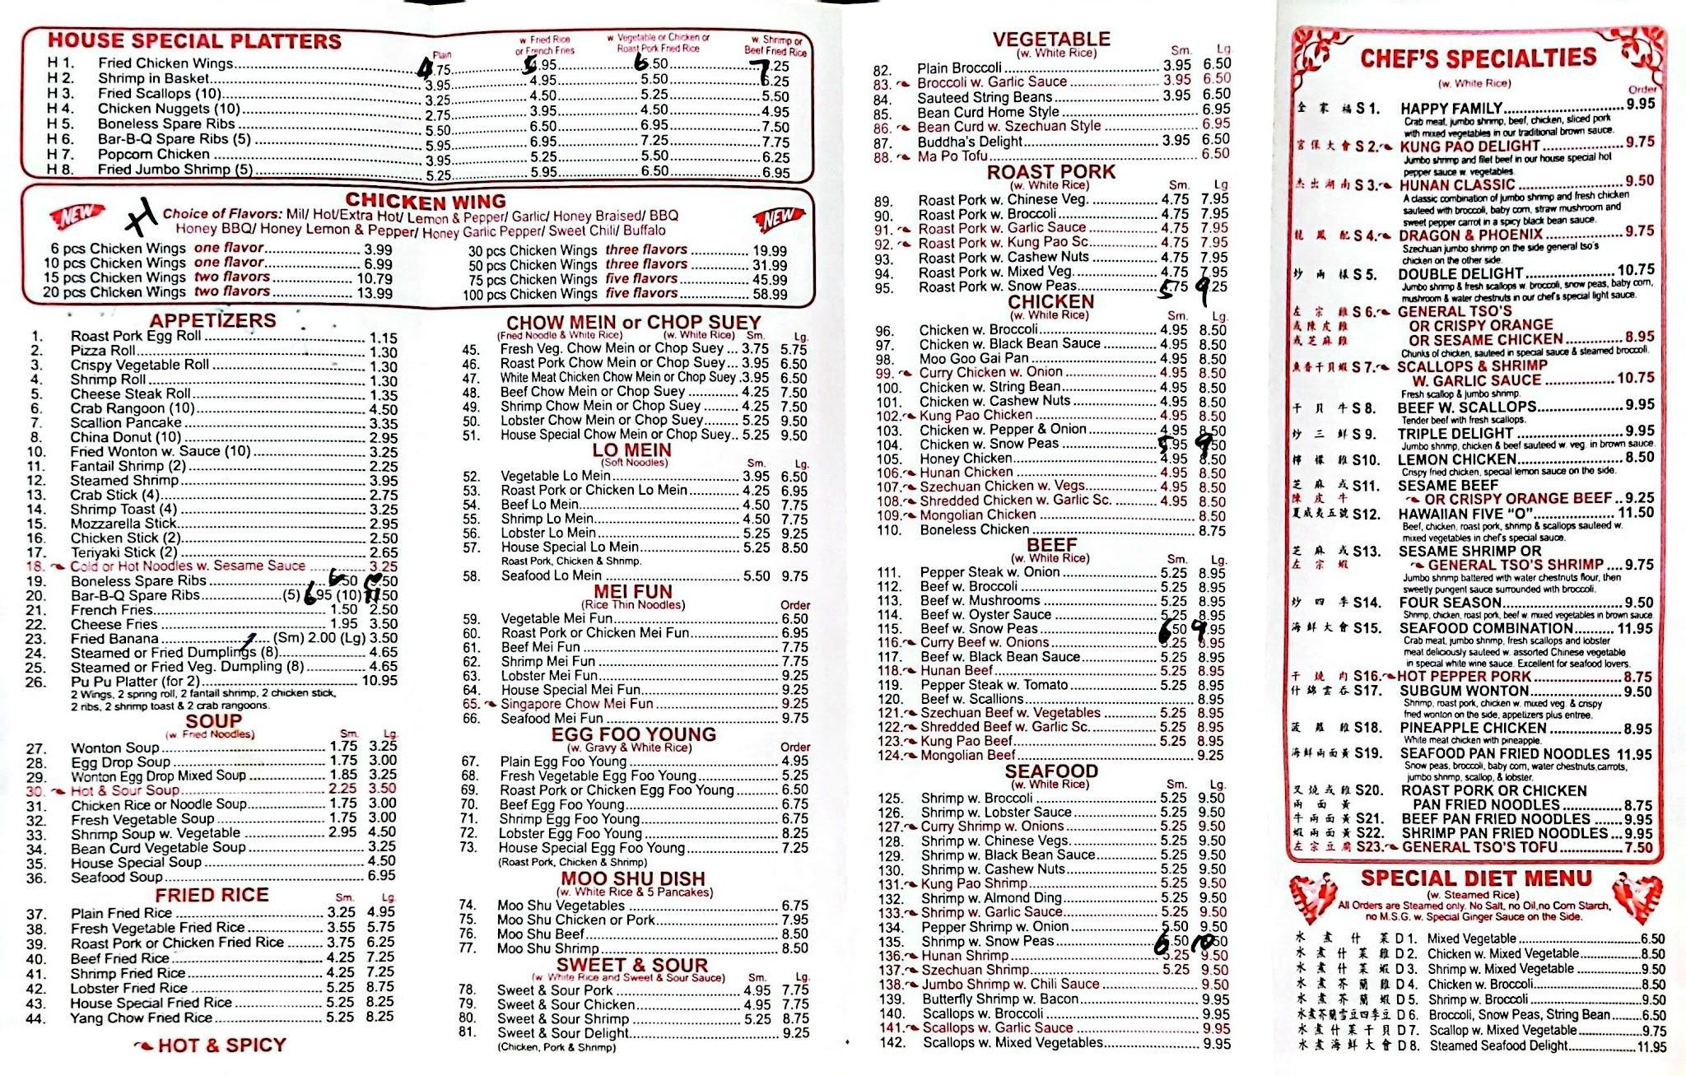

Figure 45 contains a picture of a receipt from a recent order by the author, with private information redacted.

**Figure 45**

*Order receipt photo*

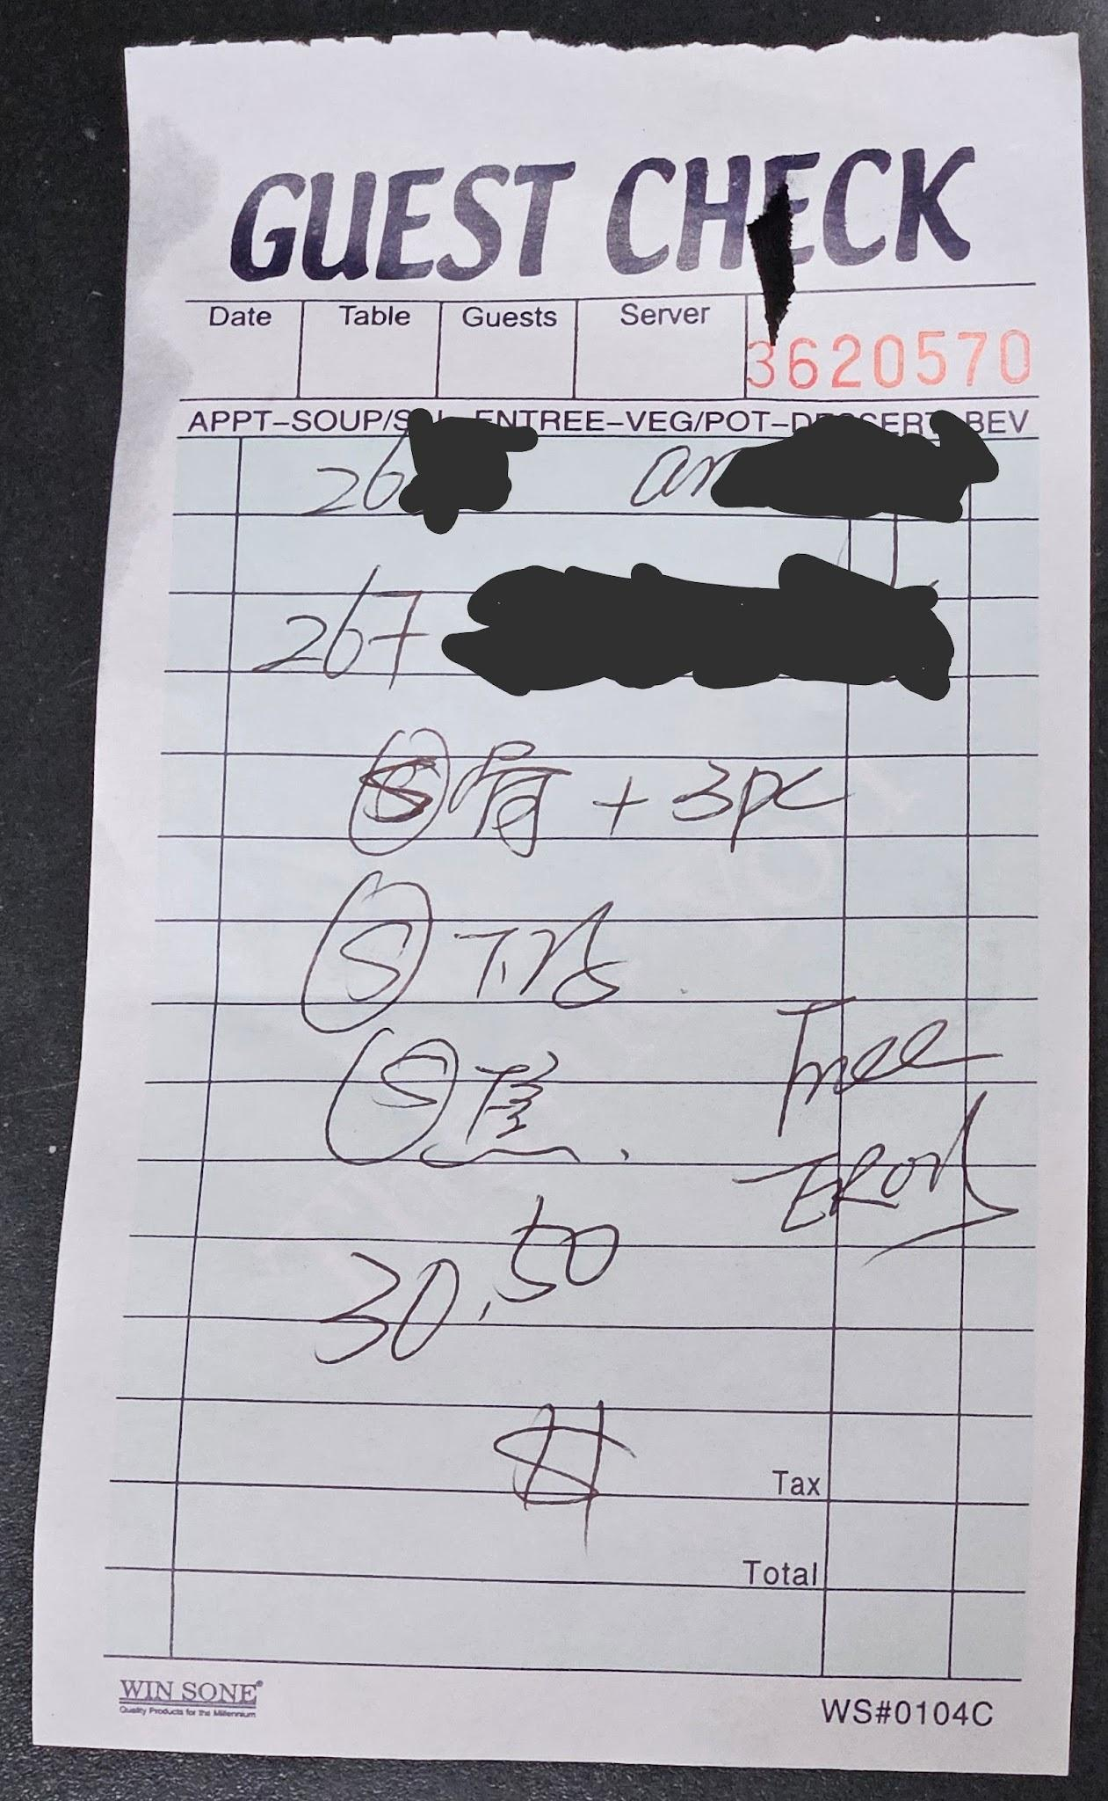

# References

Chia, A. (2024, October 15). *What Is A Data Dictionary? A Comprehensive Guide*. Splunk LLC. <https://www.splunk.com/en_us/blog/learn/data-dictionary.html>

Coronel, C., & Morris, S. (2019). *Database Systems: Design, Implementation, & Management*, 13th Edition. Cengage Learning.

Dybka, P. (2014, August 2). *Chen Notation*. Vertabelo SA. <https://vertabelo.com/blog/chen-erd-notation/>

JGraph. (n.d.). *Draw.io*. JGraph, Ltd. <https://www.drawio.com/>

MariaDB Tutorial. (2024, September 7). *MariaDB Tutorial*. <https://www.mariadbtutorial.com/>

Mockaroo. (n.d.). *Mockaroo - Random Data Generator and API Mocking Tool | JSON / CSV / SQL / Excel*. Mockaroo, LLC. <https://www.mockaroo.com/>

Nelson, C. (2020). *CIS 205: Database Management Systems - Sample Data Dictionary*. Community College of Philadelphia.

Ng, T. (n.d.). *Internal vs. External Stakeholders: Who Matters Most for Your Project's Success?* Rework.com. <https://resources.rework.com/internal-vs-external-stakeholders>

Novasak, I. (2024, November 3). *IT Project Proposal*. Southern New Hampshire University.

Refsnes Data. (n.d.). *SQL Tutorial*. W3Schools. <https://www.w3schools.com/sql/default.asp>

Simplified Guide. (n.d.). *How to import CSV files into MySQL or MariaDB*. Simplified.Guide. <https://www.simplified.guide/mysql-mariadb/import-csv>